ADDLYFT
AI-Powered Local Advertising & Monetization Platform

Business Requirements Document
Full Platform Specification — ADDLYFT Go · ADDLYFT Reach

Document Title | ADDLYFT Platform — Business Requirements Document
Version | 1.1
Date | June 4, 2026
Prepared By | Azim — Product Owner
Status | Final — Approved BRD
Classification | Internal / Confidential

▶ INTERNAL & CONFIDENTIAL — DO NOT DISTRIBUTE ◀

Table of Contents
1. Executive Summary
2. Business Objectives
3. Stakeholders
4. Scope
5. Product 1: ADDLYFT Go (Store Owner App)
6. Product 2: ADDLYFT Reach (Advertiser App)
7. Product 3: ADDLYFT Ops (Internal Operations App)
8. Hardware Requirements
9. Functional Requirements Summary
10. Non-Functional Requirements
11. Data Requirements
12. Integration Requirements
13. User Roles & Permissions
14. Assumptions & Constraints
15. Acceptance Criteria
16. Revision History

1. Executive Summary

ADDLYFT is a two-sided, AI-powered advertising and monetization platform designed to connect local retail store owners with local advertisers. The platform bridges a critical gap in the local advertising market by enabling physical retail environments — convenience stores, gas stations, salons, and other high-footfall locations — to function as measurable advertising channels at the exact moment customers are making purchasing decisions.
The ADDLYFT platform is composed of two distinct, purpose-built products:
- ADDLYFT-Go — A store owner-facing application that lets local businesses create AI-generated promotional content, Use Pre Build Content, or Can make their own content and promote their Business using 3 channels Audio, Video and social media. The platform also brings in experience in cross advertisement which highlights guaranteed monthly revenue of $49/month per active store and referral earnings up to 40% from advertisers brought in through the store owner's referral code.
- ADDLYFT-Reach — An advertiser-facing platform that allows local businesses to run hyper-local audio (15-second) and video (10-second) ad campaigns inside physical retail stores, select exact store locations, and monitor campaign performance through analytics and pricing tools.

ⓘ Purpose of This Document
This Business Requirements Document (BRD) translates validated prototypes and product specifications into actionable, developer-ready requirements for the engineering team. All requirements are assigned a unique identifier, priority classification, and contextual notes. This document is the authoritative reference for MVP scope and functionality.

The platform addresses a market where local businesses lack affordable, measurable, and hyper-targeted advertising options at the retail point of sale. ADDLYFT delivers this through a scalable SaaS model with AI automation reducing friction for non-technical store owners, and a campaign pricing model for advertisers. The MVP targets the United States market with an introductory launch discount for early advertiser adopters.

2. Business Objectives

The following business objectives define the strategic outcomes that the ADDLYFT platform must achieve. All product decisions, feature prioritizations, and requirements in this document are traceable to one or more of these objectives.
- Store Owner Monetization: Enable local store owners to monetize their in-store screens and speakers with zero technical skill required, removing all barriers to entry for non-technical retail operators.
- Hyper-Local Advertising: Provide local advertisers with hyper-local, in-store advertising placement at competitive CPM rates, targeting customers at the exact moment of purchase decision.
- Guaranteed Revenue Commitment: Guarantee store owners a minimum revenue of $49/month per store regardless of advertiser activity, establishing trust and reducing churn risk from the supply side.
- AI-Powered Content Automation: Automate AI content creation — audio scripts (15s), video scripts (10s), and social posts — to reduce onboarding friction and ongoing content maintenance for non-technical users.
- Scalable Operations Back Office: Build a scalable operations platform (ADDLYFT Ops) capable of managing thousands of stores and advertisers with minimal manual intervention.
- Rapid MVP Launch with Early Adopter Incentive: Launch an MVP within the shortest viable timeline, supported by a introductory discount for early advertiser adopters to accelerate demand-side adoption.

3. Stakeholders

The following stakeholders have defined interests in the ADDLYFT platform. All requirements have been developed with these stakeholder perspectives in mind.

Role | Description | Primary Interest
Co-Founder  Azim, Jishan, Alnoor | Azim: Leads product vision, architecture, feature development, and technical execution of the ADDLYFT platform.  Jishan: Drives advertiser acquisition, partnership development, and business growth strategy.  Alnoor: Provides strategic guidance on store acquisition, market entry, sales playbooks, and GTM execution. Supports early‑stage rollout and partnership strategy. | Building scalable AI-powered retail media technology and product innovation. Expanding advertiser network, revenue strategy, and business development. Market expansion, GTM strategy, and helping ADDLYFT scale store adoption efficiently.
Product Owner Azim | Defines product vision, validates prototypes, and owns requirements | Feature completeness, launch readiness, alignment between spec and build
Development Team | Engineers responsible for designing and building all three products | Clear, unambiguous technical requirements with no conflicting logic
Store Owners End Users — ADDLYFT Go | Local retail businesses (convenience stores, salons, cafes, etc.) using the platform to monetize in-store airtime | Easy setup, guaranteed revenue, zero technical friction, AI content tools
Advertisers End Users — ADDLYFT Reach | Local businesses purchasing in-store ad placements across the ADDLYFT store network | Effective, measurable, hyper-local ad placement with real-time performance data
ADDLYFT Ops Admins | Internal ADDLYFT operations team managing the entire platform day-to-day | Operational visibility, content moderation tools, financial reconciliation, system health
Finance / Accounting | Internal ADDLYFT finance team responsible for payout accuracy and reporting | Accurate payout records, fee tracking, reconciliation exports, tax summaries

4. Scope

4.1 In-Scope
The following features and capabilities are included in the MVP build:
- Full ADDLYFT Go application — 7-step onboarding, dashboard, AI Studio, analytics, audio engine, revenue module, referral system
- Full ADDLYFT Reach application — advertiser onboarding, campaign creation, store-level targeting, real-time analytics
- AI content generation integration — audio scripts (15s), video scripts (10s), social media posts
- In-store audio engine — music-ad cycle management with per-store preferences
- Real-time analytics for store owners, advertisers, and ADDLYFT Ops team
- Referral tracking and automated commission system tied to advertiser signups and monthly spend
- AI token top-up purchasing and monthly allocation management
- Pre-built promotions library (minimum 6 templates) for store owners
- Content moderation queue with approve / reject / escalate workflow
- Campaign lifecycle management with full status tracking
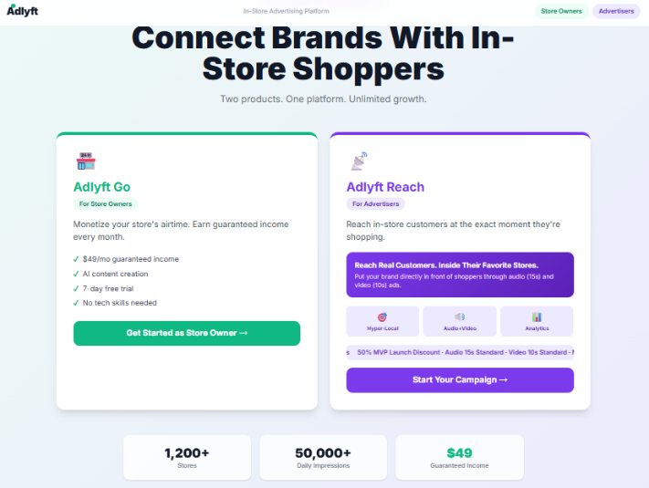
- Store onboarding pipeline with stage-based tracking and overdue alerting

5. Product 1: ADDLYFT Go (Store Owner App)

5.1 Overview
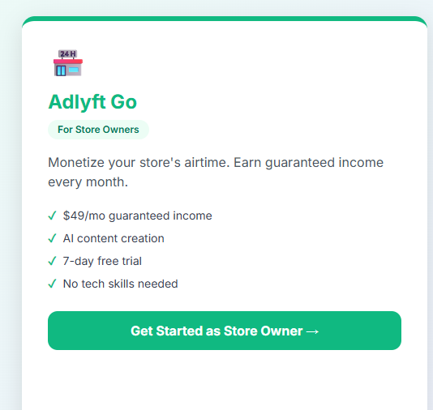
ADDLYFT Go is the store owner-facing product within the ADDLYFT platform. It enables local retail businesses to set up in-store digital advertising screens and speakers, create AI-powered promotional content, schedule that content across time slots, and earn guaranteed monthly revenue by hosting advertiser campaigns. The application is designed for non-technical users and must be operable without prior digital advertising experience. The primary design principle is simplicity without sacrificing capability.

Figure 1. ADDLYFT Go overview screen reference.

5.2 User Onboarding — 7-Step Registration Flow
The registration flow must be implemented as a clearly delineated 7-step wizard with a persistent progress indicator. Each step must validate its own fields before allowing progression to the next step. Users must be able to navigate backward through previously completed steps without losing entered data.

ⓘ Onboarding UX Requirement
The entire 7-step onboarding flow must be completable by a first-time user in under 10 minutes. All form fields must include contextual helper text or placeholder copy. Validation errors must surface inline, adjacent to the offending field — not as a page-level alert.

01 Step 1 — Account Setup
Collect the store owner's personal account information. All fields are mandatory unless noted.

Field | Type | Validation Rules
First Name | Text | Required, max 50 chars
Last Name | Text | Required, max 50 chars
Email Address | Email | Required, unique in system, valid email format
Phone Number | Tel | Required, valid US format
Password | Password | Required, must meet platform security policy (min 8 chars, 1 uppercase, 1 number, 1 special char)
Confirm Password | Password | Required, must match Password field
Business Name | Text | Required, max 100 chars
Business Type | Dropdown | Required. Options: Gas Station with C-Store, Liquor Store, Smoke Shop, C – Store with no Gas, Pharmacy, Salon & Spa, Barbershop, Laundromat, Cafe, Restaurant, Retail Store, Other
Address | Num/Text | Required, full street address
City | Text | Required
State | Dropdown | Required, US states
ZIP Code | Text | Required, valid US ZIP format
Terms of Service | Checkbox | Required — must be checked to proceed
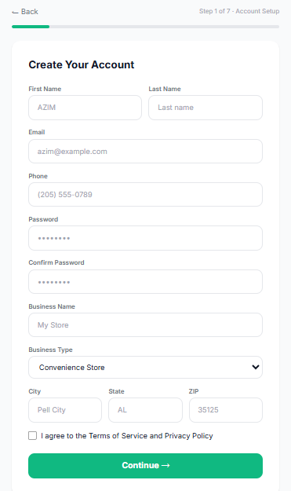

02 Step 2 — Store Setup
Collect physical store details and operating information for the primary store location.

Field | Type | Notes
Store Name | Text | Required
Store Address | Text | Required, full street address with City, State and Zip Code
Store Phone | Tel | Required
Store Website | URL | Optional
Opens At | Dropdown | Required. Range: 5:00 AM through 10:00 AM (hourly increments)
Closes At | Dropdown | Required. Range: 6:00 PM through 12:00 AM (hourly increments)
Daily Customer Footfall | Dropdown | Required. Options: Up to 250/day, 500/day, 750/day, 1,000/day, 1,250/day, 1,500/day, 2,000/day, 3,000/day, 4,000/day, 5,000/day

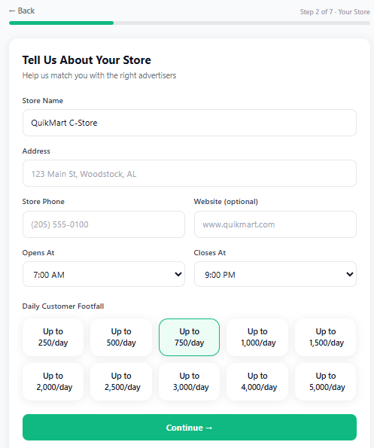
03 Step 3 — Plan Selection
Three pricing tiers are presented as visually distinct selectable cards. Selection must be required before proceeding. The selected plan persists through the remainder of the flow and must be shown in all subsequent confirmation screens and the order summary.
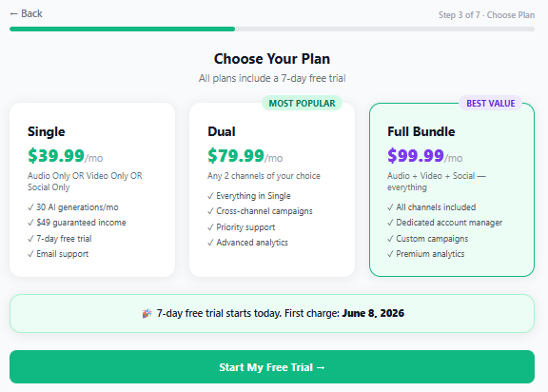
Plan Name | Monthly Price | Channels Included | AI Generations | Key Inclusions
Single | $39.99/mo | Audio channel | 1 per Month | Audio channel, basic analytics, 7-day free trial
Dual | $79.99/mo | Audio + Video | 2 per Month | Audio + Video, advanced analytics, priority support
Full Bundle | $99.99/mo | Audio + Video + Social | 3 per Month | Audio + Video + Social, full analytics suite, dedicated account support, $49/mo revenue guarantee

⚠ Billing Rule — Free Trial
The 7-day free trial begins immediately upon account creation. The store owner's payment method is NOT charged during the trial period. The first charge occurs exactly 7 days after signing up. This rule must be enforced at the payment processing layer, not just in the UI. A clear notice must appear on Steps 5 and 7: "You will not be charged until your 7-day free trial ends."

04 Step 4 — Store Lineup
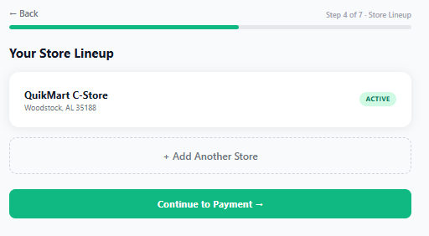
After establishing the primary store in Step 2, the user may add additional store locations in this step. Each additional store entry requires: Store Name, Address, City, ZIP Code, and Daily Footfall selection. The total subscription cost must be updated dynamically in real time as stores are added or removed. Each store added after the first creates an additional subscription charge at the selected plan rate. The Full Bundle plan is the only plan that supports multiple store locations by default.

05 Step 5 — Payment Method Selection
The user selects their preferred payment method. All options must be available and clearly presented. A persistent notice must be displayed: "You will not be charged until your 7-day free trial ends on [calculated date]."
- Credit / Debit Card — Visa, Mastercard, American Express
- Bank Account (ACH) — Direct bank transfer via ACH
- PayPal — PayPal OAuth redirect and token storage
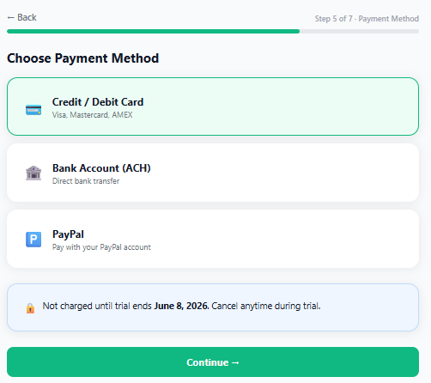
06 Step 6 — AI Content Studio Preview
This step introduces the AI Content Studio to the store owner before checkout. It is both educational and an upselling opportunity. It must display clearly without being coercive.
Display the monthly AI generation allowance based on the selected plan. The system must clearly show the user’s included monthly generation quota and remaining token balance for the active billing cycle. AI Token Top-Up upsell options must be displayed as selectable cards with savings callouts:
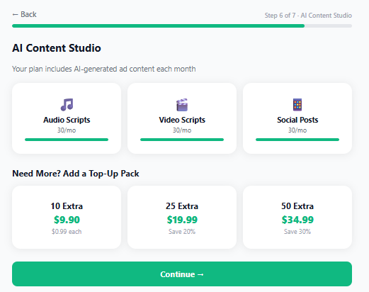
Top-Up Pack | Price | Savings | Notes
10 Extra Tokens | $4.99 | — | Standard rate
25 Extra Tokens | $9.99 | — | Mid-tier pack
50 Extra Tokens | $17.99 | Best value | Matches validated platform pricing

Note: Audio ads are 15 seconds standard. Video ads are 10 seconds standard. Each generation action (regardless of which content type) deducts exactly 1 token.

07 Step 7 — Payment & Checkout
Final checkout step. Must display a clear, itemized order summary and collect payment details.
Order Summary must display: Plan name, monthly price per store, store count, total monthly amount, trial start date, trial end date, first charge date.

Form Field | Type | Notes
Cardholder Name | Text | Required for card payment
Card Number | Masked text | PCI-DSS compliant tokenization required
Expiry Date | MM/YY | Required for card payment
CVV | Masked text (3–4 digits) | Never stored; used only for authorization
Billing Address | Text | Required; "Same as store address" checkbox available
City / State / ZIP | Text / Dropdown / Text | Required for billing address
Promo Code | Text | Optional; must validate against active promotions table

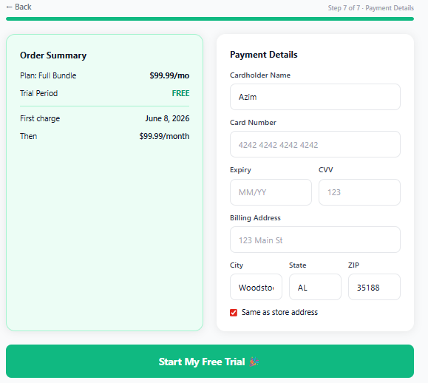
An SSL/security trust badge must be displayed prominently on the checkout page.

Onboarding Completion Screen
Upon successful checkout, a personalized welcome screen must be displayed with the following elements:
- Personalized welcome message addressing the store owner by first name
- Trial end date and first charge date clearly displayed
- Number of active stores registered
- Monthly guaranteed revenue confirmation: "$49/mo guaranteed" Payout should only trigger if the customer stays with ADDLYFT for minimum of 3 Months, Payout will be Quarterly.
- "What's Next" steps: (1) Audio/video system activated within 24–48 hours, (2) Browse promotions or create first AI ad, (3) First $49 payout on billing date
- Unique Referral Code displayed prominently in format: ADDLYFT-[NAME]-[4-digit number]
- Referral commission example: "An advertiser spending $390/mo → You earn $156/mo automatically"
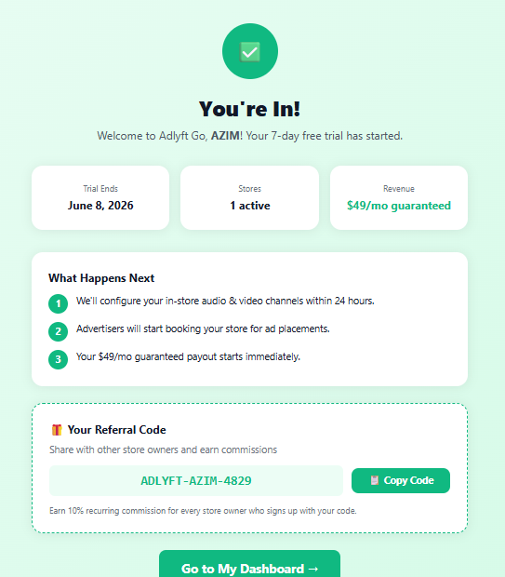

5.3 Dashboard Requirements
The ADDLYFT Go dashboard is the primary interface for store owners after onboarding. It must be organized as a tabbed interface with the following tabs accessible from a persistent navigation bar.

5.3.1 Overview Tab
The default landing tab post-login. Displays top-level KPI cards and quick-action shortcuts.

KPI Card | Data Displayed | Notes
Monthly Revenue | $49 base + any referral commissions | Updated on billing cycle
AI Tokens | Used / Remaining (e.g., 27 / 30) | Resets on billing date monthly
Active Stores | Count of stores on account | Links to store list view
Ads This Month | Total ad plays this billing month | Aggregate across all stores
Trial Days Left | Days remaining in free trial | Hidden after trial conversion

Quick Action buttons: Browse Promotions, Create with AI, View Revenue. Each button navigates to the corresponding tab. Per-store status card(s) must be displayed, showing the store name, plan, and current status badge (Active / Trial / Suspended).
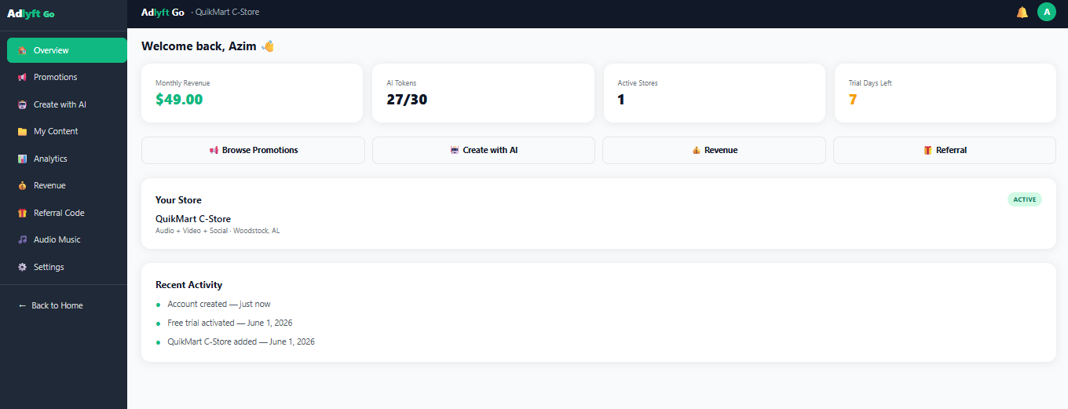

5.3.2 Promotions Tab (Pre-Built Content Library)
A curated library of ready-made promotional content pre-built by the ADDLYFT team. Store owners can browse, preview, and schedule this template without using any AI tokens.
Required pre-built promotions:
- Weekend Special 20% Off Cold Drinks
- Happy Hour Deals
- New Arrival Alert
- Flash Sale Today
- Loyalty Reward
- Seasonal Offer
Each promotion card must display title, available channel badges (Audio, Video, Social), Preview button, and Select & Schedule button. The scheduling modal must allow selection of: Time of Day (Morning, Afternoon, Evening, Night) and Social Post time.
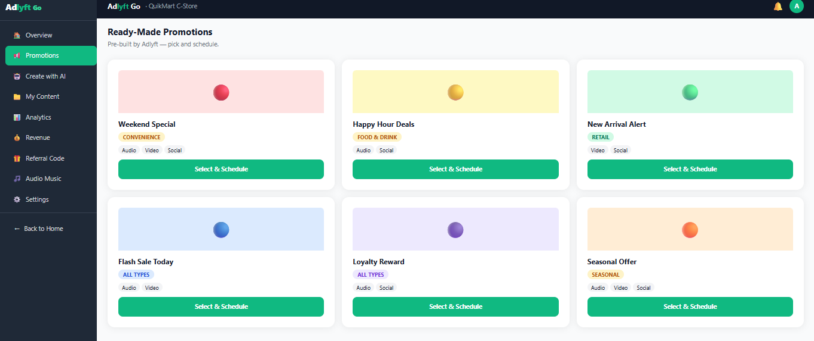

5.3.3 Create with AI Tab
The primary AI content generation interface. Allow store owners to generate custom ad content using a text prompt and an optional image.
Step 1 — Image Upload (Optional): Drag-and-drop or click-to-upload interface. Accepted formats: PNG, JPG. Maximum file size: 5 MB. The uploaded image provides visual context to the AI generation engine.
Step 2 — Text Prompt: Free-text input field with a 500-character limit (character counter displayed). Generate button triggers AI generation. Each generation deducts exactly 1 AI Token from the monthly allocation. The system must display the remaining token count before and after each generation’s action.
AI Output Display — Three Cards Generated Simultaneously:

Content Card | Content Type | Duration / Format | Actions Available
Audio Script | Script text for audio ad | 15 seconds standard | Preview, Use This
Video Script | Script text for video ad | 10 seconds standard | Preview, Use This
Social Post | Image or Video + Caption text + hashtags | Text-based, platform-agnostic | Preview, Use This

Scheduling: After selecting content via "Use This," the user selects: Time of Day (Morning, Afternoon, Evening, Night) and Days of Week (individual checkboxes: Mon, Tue, Wed, Thu, Fri, Sat, Sun). Save & Schedule button commits the schedule. Date Start to Stop.
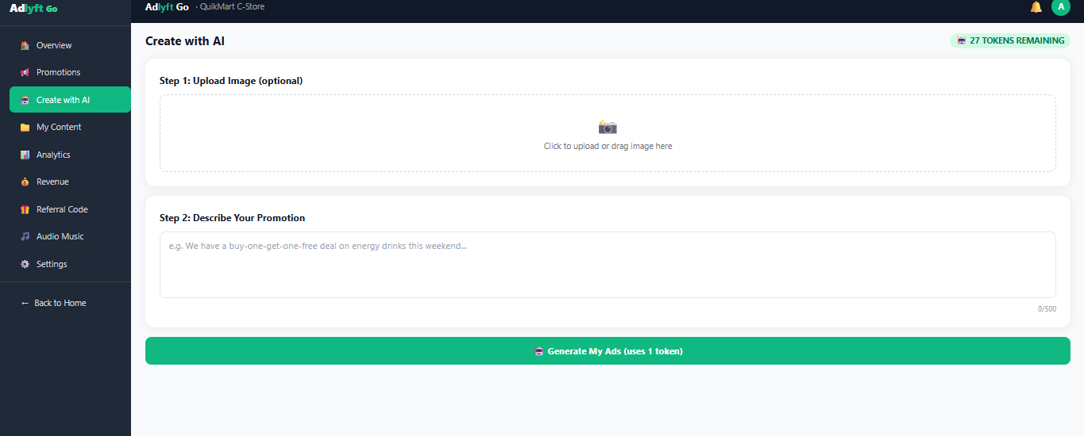

5.3.4 My Content Tab
A management view of all content associated with the store owner's account across all stores and channels.
- Create Custom Content: Users can create and upload their own content manually by uploading audio or video files, or by entering text for social media content. Each item must support preview, selection, and scheduling based on the chosen channel.
- Filter by Type: All, Audio, Video, Social
- Filter by Status: Live, Scheduled, Draft
- Each content item displays: content type icon, title, schedule summary, status badge, edit button, Delete button
- Deletion must trigger a confirmation dialog before permanent removal
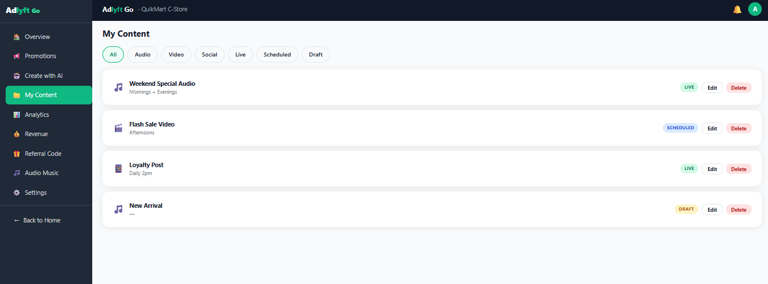

5.3.5 Analytics Tab
Performance analytics for the store owner's ad content across all stores and channels.

Element | Description
Time Filter | Today, This Week, This Month
KPI Metrics | Total Ad Plays, Audience Reached, Social Impressions, Daily Average
Daily Plays Chart | Line or bar chart showing ad plays per day for the selected period
Content Mix Chart | Pie or donut chart showing percentage breakdown: Audio %, Video %, Social %
Time-of-Day Heatmap | Grid: Days of week (Mon–Sun) × Time slots (Morning / Afternoon / Evening / Night). Cell intensity indicates play volume.
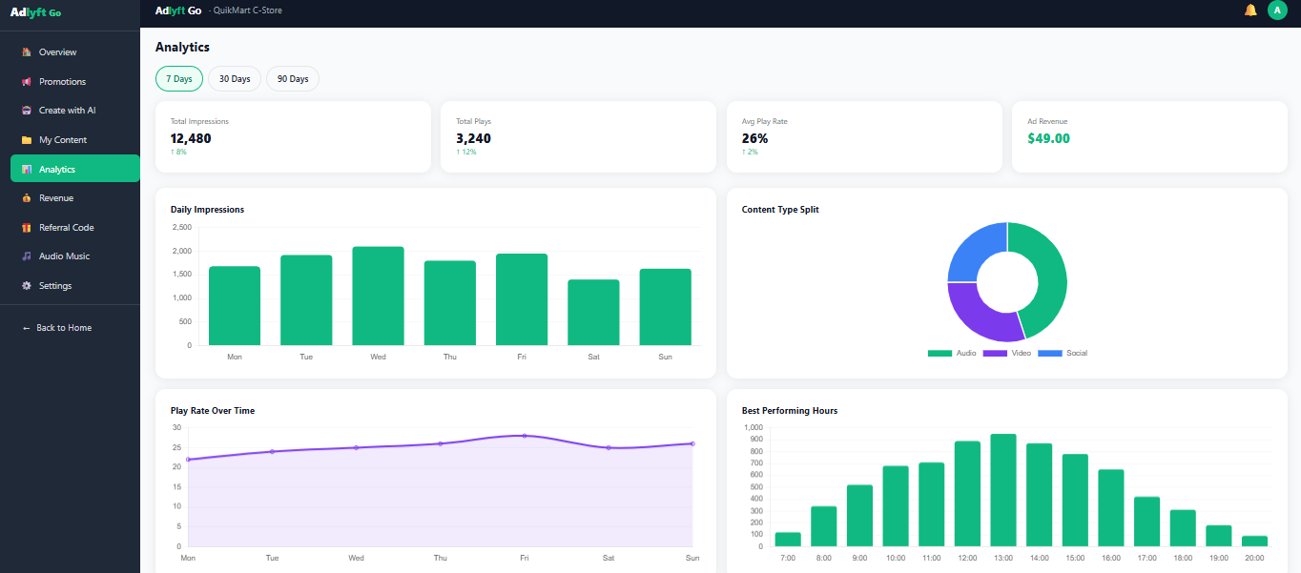

5.3.6 Audio Music Dashboard
Manages the in-store audio experience, including the music-to-ad cycle and music preference configuration. This tab must include an explanatory visual diagram of the audio cycle presented clearly for non-technical users. Limit the Time frame of Song to 2 Minutes, at 1 Minute 55 Seconds the Songs Start Fading and will stop at 2 Minute completely after which two adds of 15 Seconds Each will be played and then next song and repeat. Songs list should be editable or customized according to the customer choice.
In-Store Audio Cycle:

🎵 Song (~2 min) | ➡ | Fade Out (5 sec) | ➡ | Ad 1 (15 sec) | ➡ | Ad 2 (15 sec) | ➡ | Next Song (Repeat)

Music Preference Controls — Per Store:

Preference Category | Selection Type | Options
Genre | Multi-select | Pop, R&B/Soul, Hip-Hop, Country, Rock, Jazz, Classical, Latin, Electronic, Reggae, Gospel, Afrobeats, K-Pop, Indie, Blues, Instrumental
Language | Single or Mixed | English, Spanish, Hindi, Punjabi, Arabic, French, Portuguese, Urdu, Korean, Japanese, Any/Mixed
Mood & Style | Multi-select | Upbeat & Energetic, Chill & Relaxed, Feel-Good, Party Vibes, Morning Fresh, Evening Vibes, Family Friendly, Instrumental Only, Romantic, Focus
Popularity | Single-select | Top Charts, Popular (Top 1,000), Mixed Popular & Indie, Indie & Underground, Any
Favourite Artists | Tag input (optional) | Free-text artist names added as tags; used for rotation priority
Explicit Lyrics | Toggle (On/Off) | Off by default. Family-friendly stores should default to Off.

Audio System Status Display: Audio System status badge (Active / Inactive), Current Mode summary text, Next Ad Slot countdown timer, Ads in Queue count.
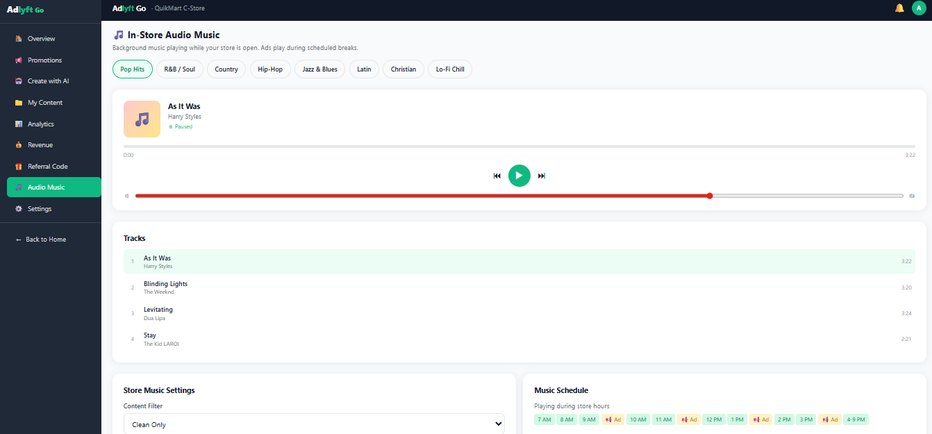

5.3.7 Revenue Tab
Displays the store owner's earnings in detail. Must show both the guaranteed minimum component and any referral commission component separately.
- Total Earned This Month — broken down as: Fixed Guarantee ($49) + Referral Commissions (The Referral Commission is only Valid until the Advertiser is Active if for any reason the Advertiser becomes inactive the commission will also stop)
- Revenue breakdown table: Source, Type, Amount, Date, Status
- Payout history for previous months
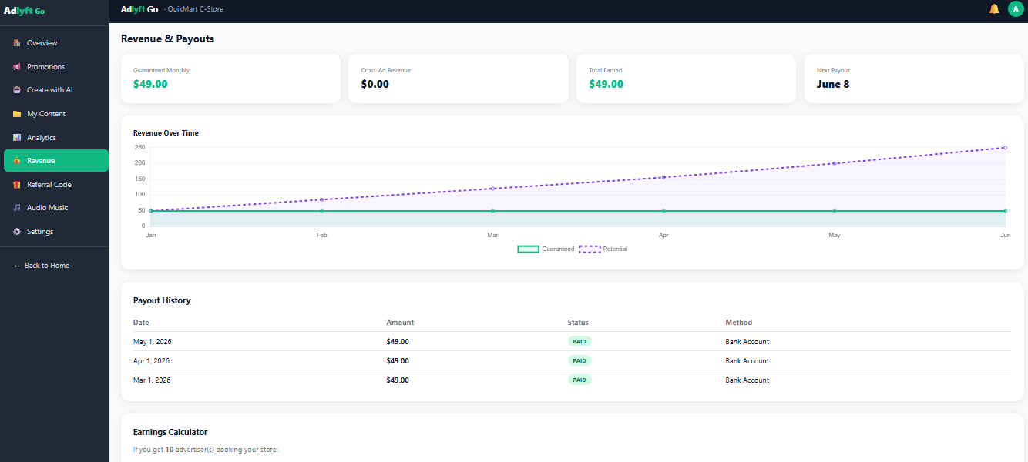

● Revenue Guarantee Requirement
The $49/month guaranteed payout to each active store must be reflected in the payout ledger on every billing date regardless of actual advertiser campaign revenue. The difference between actual advertiser revenue generated by the store and the $49 guarantee is covered by ADDLYFT as a business cost. The payout system must enforce this unconditionally.

5.3.8 Referral Code Tab
- Display the store owner's unique referral code in large, clearly readable format
- Copy-to-Clipboard button (one-click copy) and Option to send the Link to download the app and code using email or Text.
- Referral earnings summary (total earned from referrals, referral count)
- Commission calculator example displayed to user: e.g., "If your referred advertiser spends $390/mo, you earn $156/mo automatically"
- Referral code format: ADDLYFT-[NAME]-[4-digit number] (e.g., ADDLYFT-JAMES-4821)
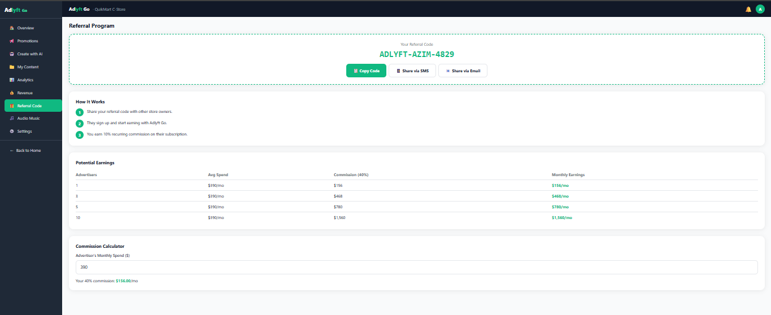

5.3.9 Settings Tab
Account-level and store-level settings management. Includes:
- Account Settings: Name, email, phone update
- Store Settings: Per-store details, hours, footfall update
- Notification Preferences: Email and push notification opt-in/out per event type
- Password Change: Requires current password verification
- Support: Creating a Ticket for any issue. Should have Subject, Detail message, Contact Name, Phone number and email address.
- Billing Management: View current plan, next charge date, update payment method, download invoices, email Invoice to customers email every month automatically.
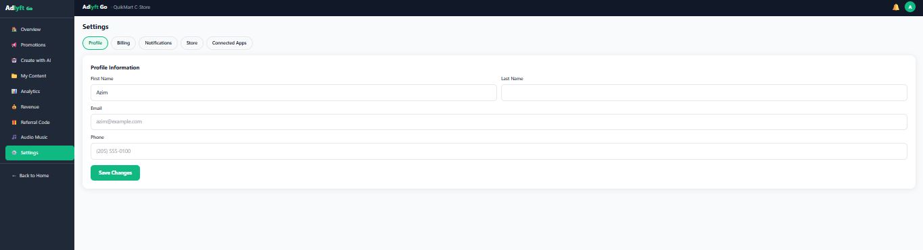

6. Product 2: ADDLYFT Reach (Advertiser App)

6.1 Overview
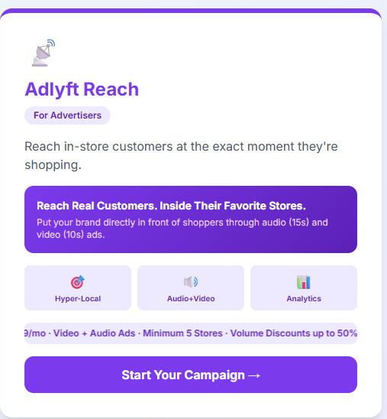
ADDLYFT Reach is an advertiser-facing product within the ADDLYFT platform. It enables local businesses to discover the ADDLYFT store network, create hyper-local audio and video ad campaigns, select target store locations with precision, and monitor campaign performance in real time. The platform is designed for local business owners who may not have a dedicated marketing team and need streamlined, self-serve campaign management experience.

6.2 Reach User Journey — Step-by-Step App Flow
ADDLYFT Reach must be implemented as a guided advertiser journey that moves from awareness and campaign setup into live campaign management. The flow is intentionally self-serve and optimized for local businesses with limited media-buying experience. The product must clearly communicate value, simplify targeting and pricing, and provide enough transparency for advertisers to confidently launch campaigns without sales-team intervention.
Figure 2. ADDLYFT Reach guided user journey reference.

6.2.1 Reach Overview / Landing Experience
The ADDLYFT Reach landing experience must position the product as a hyper-local, in-store advertising platform for advertisers. The screen must communicate the core value proposition: advertisers can reach real customers inside selected stores using audio and video ad placements. The landing view must prominently display three value pillars: Hyper-Local Targeting, Audio + Video Dual-Channel Delivery, and Real-Time Analytics. A primary call-to-action button must route the advertiser into the guided campaign flow. The current MVP promotional message must be visible on the landing page and clearly state the launch offer, standard ad durations, and minimum store requirement.
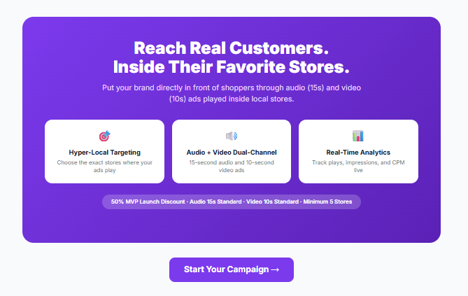

6.2.2 Step 1 — Business Information
The first step in Reach onboarding must collect advertiser business details. Required fields include Business Name, First Name, Last Name, Business Email, Phone, City, State, and ZIP Code. Website is optional. The form must also ask whether the advertiser was referred by an ADDLYFT Go store owner. If the advertiser selects “Yes,” the UI must reveal a referral code input field dynamically without reloading the page. Each field must validate inline before progression is allowed. The progress indicator must show this screen as Step 1 of 6 in the setup sequence.

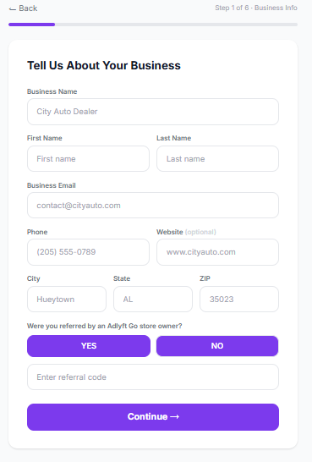

6.2.3 Step 2 — Business Category Selection
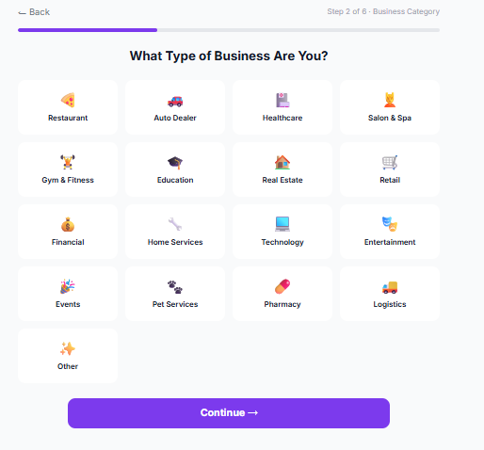
Step 2 must capture the advertiser’s business category using a visual category grid. The advertiser must select one category before continuing. Category options must support a broad advertiser base and include at minimum the categories represented in the validated prototype: Restaurant, Auto Dealer, Healthcare, Salon & Spa, Gym & Fitness, Education, Real Estate, Retail, Financial, Home Services, Technology, Entertainment, Events, Pet Services, Pharmacy, Logistics, and Other. The selected tile must persist visually and be stored in the advertiser account profile for campaign personalization and downstream reporting.

6.2.4 Step 3 — MVP Offer Confirmation
Step 3 must clearly present the MVP launch offer before the advertiser builds a campaign. The interface must compare a normal monthly price against the discounted launch price for the illustrated default scenario and explain that the advertiser is receiving a 50% MVP launch discount. Supporting benefit bullets must reinforce early-adopter value, including discounted plays, dedicated onboarding, featured placement, and direct founding-team access. The screen must end with a clear action button that lets the advertiser claim the discount and proceed into campaign design.

⚠ Early Adopter Discount
For the MVP launch period, all new advertisers must automatically receive a 50% introductory discount applied to their first billing cycle. The discount must be tracked in the advertiser record and the transaction ledger. Engineering must confirm with product the duration of the early adopter window and the mechanism for disabling the discount after the promotion period ends.

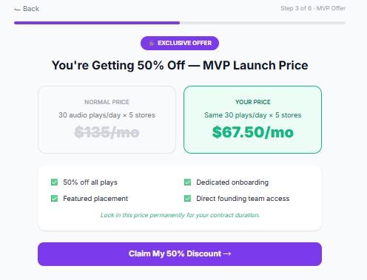

6.2.5 Step 4 — Build Your Campaign
The campaign builder is the core configuration step in Reach and must support channel selection, play-volume selection, store-count selection, and automatic pricing calculation. Advertisers must be able to run Audio only, Video only, or both channels together. Audio ads are 15 seconds standard; video ads are 10 seconds standard. Advertisers Choose their desired plan. The pricing engine must update instantly as the advertiser changes the store count. The Pricing Model should be very simple. As from the below picture the price is set for 5 stores as that’s the minimum. The screen must show a detailed cost breakdown including per-store costs, volume discount, MVP discount, total monthly amount, and total savings. A volume comparison table must also be shown to help advertisers understand how total cost, impressions, and CPM change as store count increases.
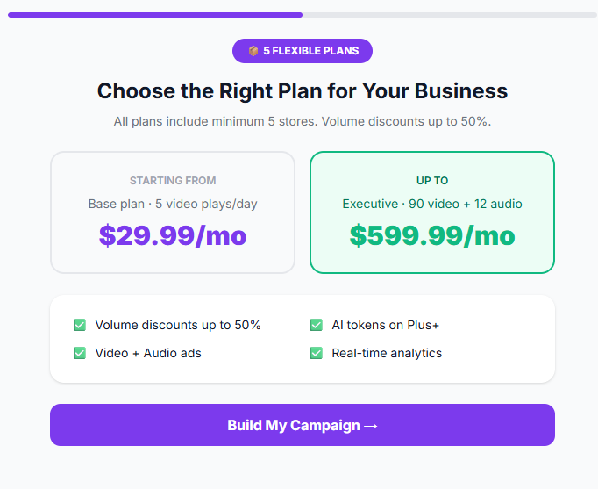
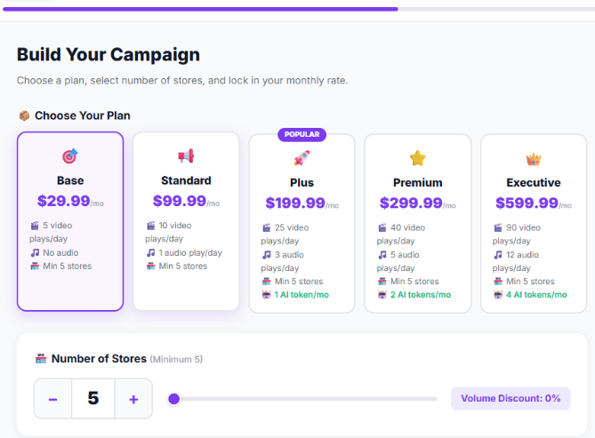

6.2.6 Step 5 — Choose Store Locations
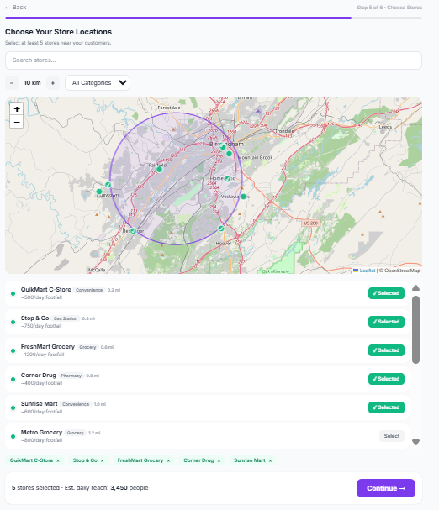
The advertiser must be able to choose store locations using a searchable, filterable map-and-list experience. The interface must allow store search, category filtering, and radius adjustment around a market center. Stores must display location, category, estimated footfall, and availability status. The advertiser must be required to select at least five stores before continuing. Selected stores must be visible as tags or chips, and the bottom summary bar must dynamically display selected-store count and estimated daily reach. Unavailable stores must be visually differentiated and must not be selectable. Only the stores which have chosen all bundle plans in ADDLYFT Go must appear in the map.
Stores belonging to the same business category as an advertiser will be automatically excluded from the advertiser’s target list to prevent category conflict. When an advertiser selects their business category, all ADDLYFT Go stores in the same category will be removed from the available store list. This ensures no store displays ads from direct competitors and maintains trust within the ADDLYFT network.

6.2.7 Step 6 — Campaign Review & Pricing Confirmation

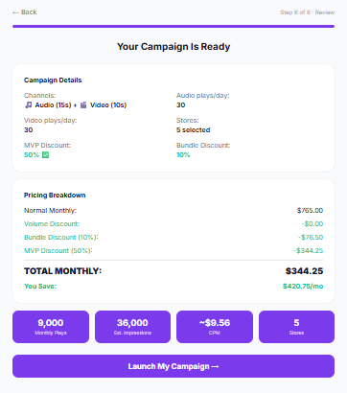
Before final submission, Reach must provide a consolidated review screen showing campaign configuration, selected channels, daily play counts, store count, applied discounts, and campaign economics. This page must summarize normal monthly pricing, volume discount, MVP discount, total monthly spend, and total monthly savings. It must also show projected monthly plays, estimated impressions, effective CPM, and selected-store count. This screen acts as the final advertiser confirmation point before ad creation and submission.

6.2.8 Step 7 — Create Ads / Submit Campaign
Reach must support three ad-creation paths before campaign submission: Ready-Made templates, AI-generated creative, and user-uploaded media. Ready-Made cards must be preview able and schedulable. The AI path must accept a free-text description and generate at least an audio script and video script aligned to Reach ad specifications. The Upload path must accept advertiser-supplied audio and video assets, with audio limited to approved audio formats and video limited to approved video formats and duration. Once the advertiser submits the campaign, the system must display a confirmation state that summarizes budget, store count, and next steps, and must clearly state that the campaign is under review before going live.
Ad Format | Duration | Placement | Notes
Audio Ad | 15 seconds | In-store audio system — plays between music tracks in the ADDLYFT audio cycle | Must not exceed 15 seconds. Submitted as audio file or script for production.
Video Ad | 10 seconds | In-store display screens | Must not exceed 10 seconds. File format and resolution specs to be confirmed by engineering team.
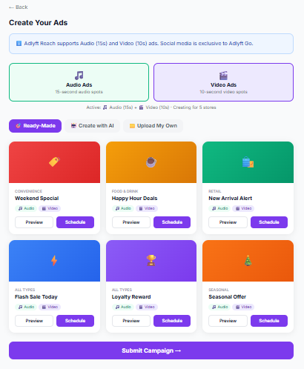
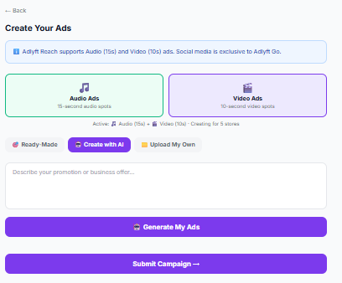
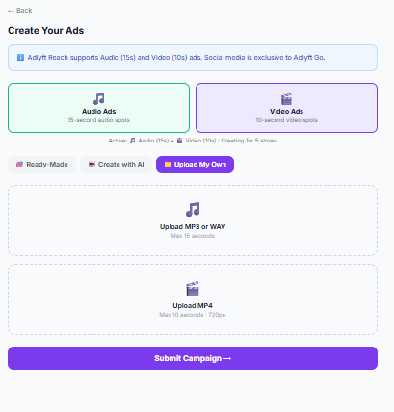
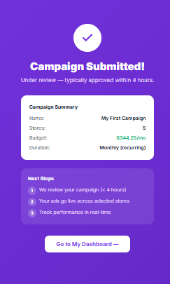

State | Description | Triggered By
Pending Review | Campaign submitted and awaiting ADDLYFT Ops approval and content moderation | Advertiser submits campaign
Active | Campaign approved and currently running live in selected stores | Ops Admin approves
Paused | Campaign temporarily halted; can be resumed by advertiser or admin | Advertiser or Admin action
Completed | Campaign end date has been reached; no longer serving | System automated (date-triggered)
Rejected | Campaign failed content moderation review; advertiser notified with reason | Ops Admin rejection action

Campaign Lifecycle States

6.3 Reach Dashboard Requirements
After submission, advertisers must have access to a multi-tab dashboard where they can monitor campaign health, manage campaigns, review targeting footprint, analyze performance, view billing history, and update profile settings. The dashboard must be accessible on mobile and desktop, and navigation must be available through both persistent sidebar navigation and a mobile bottom navigation pattern.

6.3.1 Overview Tab
The Overview tab must summarize the advertiser account with KPI cards such as Active Campaigns, Total Impressions, Monthly Spend, and current account or campaign status. It must also show quick access to create a new campaign and provide a card-based summary of current campaigns with their store count, monthly budget, and approval state.
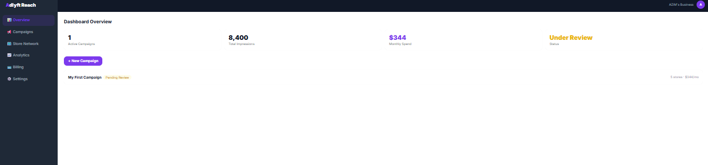

6.3.2 Campaigns Tab
The Campaigns tab must provide a filterable campaign table with campaign name, store count, status, monthly budget, impression totals, and advertiser actions. Status filters must at minimum support All, Active, Pending, Paused, and Completed. Advertisers must be able to view campaign state and perform allowed self-service actions such as edit or pause where business rules permit.
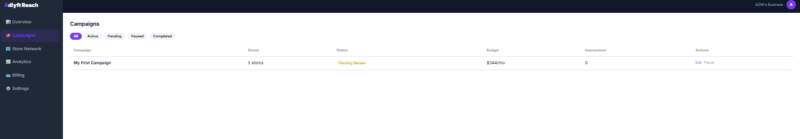

6.3.3 Store Network Tab
The Store Network tab must display the reachable store inventory in card format with location, category, estimated footfall, and a clear action to add a location into a future campaign. This tab functions as an advertiser discovery tool and should help advertisers understand network breadth before launching or expanding campaigns.
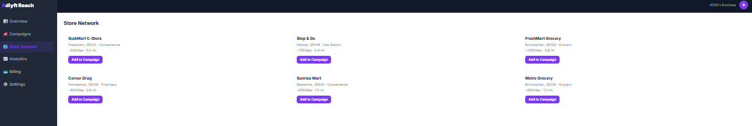

6.3.4 Analytics Tab
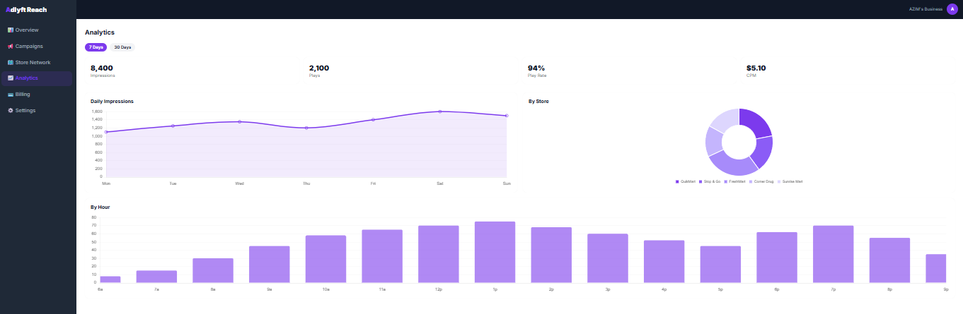
The Analytics tab must show campaign performance over selectable time periods. At minimum it must display Impressions, Plays, Play Rate, and CPM, supported by visualizations such as Daily Impressions, By Store, and By Hour. Analytics must be current enough to support meaningful campaign management and should align with the live impression and play-event pipeline used across the platform.

6.3.5 Billing Tab
The Billing tab must present the advertiser’s current plan, monthly spend, billing cadence, and invoice history. Historical billing rows must include billing date, amount, and payment status. If a discount is active, the advertiser must be able to see that the account is under an MVP launch offer or other promotional state.
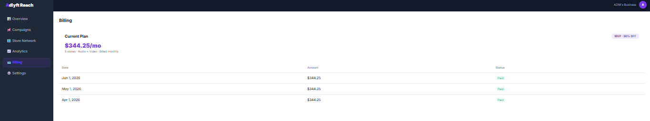

6.3.6 Settings Tab
The Settings tab must allow the advertiser to manage account identity, contact information, and notification preferences. The MVP must support business name editing, email editing, and notification toggles such as email notifications and SMS alerts. Changes must save successfully without requiring support intervention. Support box where they can request assistance as given in ADDLYFT Go feature.
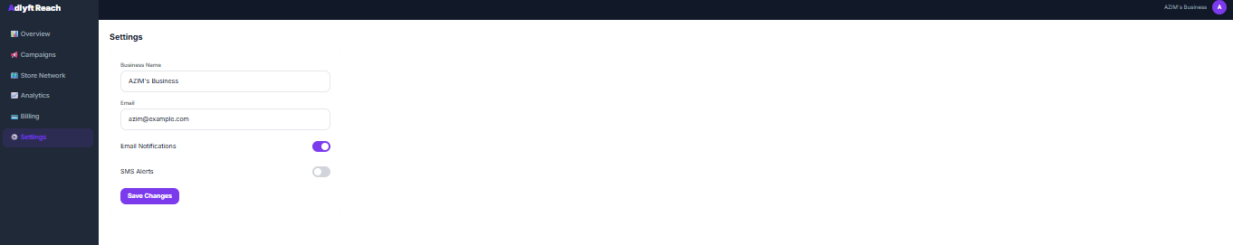

7. Product 3: ADDLYFT Ops (Internal Operations App)

7.1 Overview
ADDLYFT Ops is an internal web application used exclusively by the ADDLYFT operations team. It serves as the comprehensive back-office for every operational dimension of the platform — from store and advertiser lifecycle management to financial reconciliation, content moderation, and system configuration. Access to ADDLYFT Ops must be restricted to authenticated ADDLYFT staff with role-appropriate permissions. It must not be accessible to external users (store owners or advertisers).

7.2 Navigation Structure
The sidebar navigation must be implemented as a hierarchical, collapsible menu with the following structure and modules:

Nav Group | Module / Page | Badge / Counter
Overview | Dashboard | Live KPI refresh
Platform Management | Stores | Pending count badge
Advertisers | Pending count badge
Campaigns | Pending Review count badge
Payouts | Pending payout count badge
Onboarding Pipeline | Pipeline View | Overdue count badge
Finance | Finance & Reconciliation | —
Moderation | AI Moderation Queue | Queue count badge
Escalated Reviews | Escalated count badge
Creative Tools | Ad Creative Studio | Pending requests badge
Configuration | Pricing Config | —
Notification Center | —
System Health | Alert badge if degraded
Platform Settings | —
Reporting | Reports & Analytics | —
User Management | User Management | —
Support | Support Tickets | Open ticket count badge

7.3 Dashboard KPIs (Real-Time)
The Ops Dashboard is the first screen upon admin login. All KPI cards and the activity feed must reflect live platform data with a refresh interval not exceeding 5 seconds.
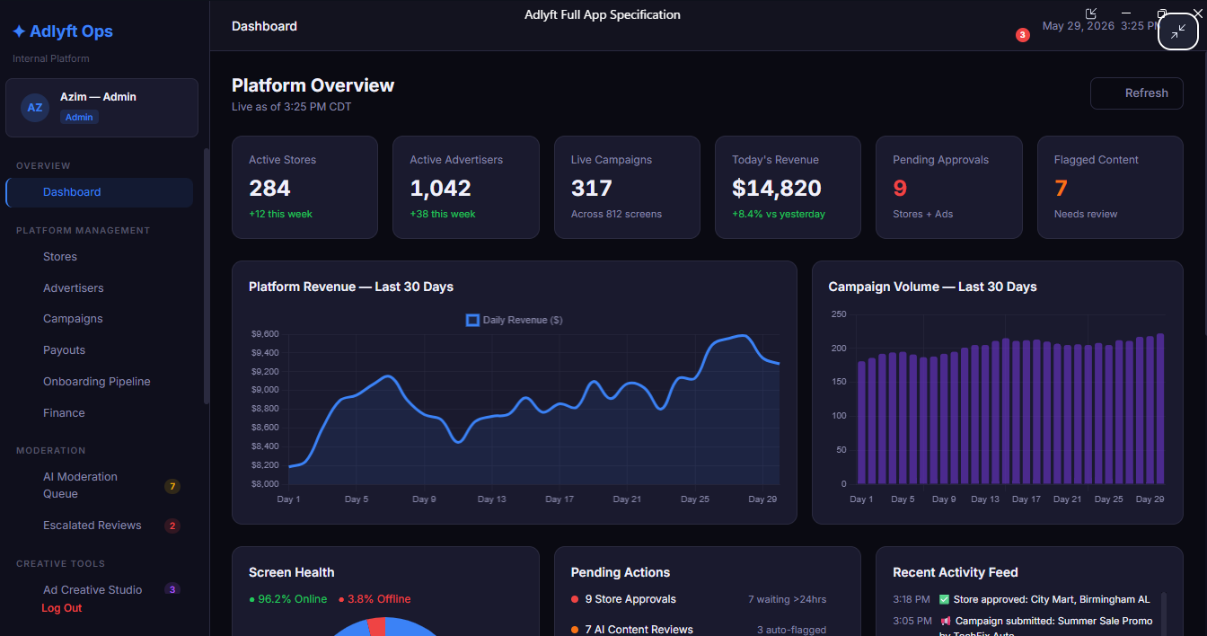

KPI Card | Metric Displayed | Secondary Indicator
Active Stores | Total count of stores with Active status | Δ from 7 days ago (e.g., +3 this week)
Active Advertisers | Total count of advertisers with Active status | Δ from 7 days ago
Live Campaigns | Total count of campaigns with Active status | Number of screens currently serving ads
Today's Revenue | Total platform revenue generated today (USD) | Day-over-day % change
Pending Approvals | Total items awaiting admin approval (stores + campaigns) | Direct link to queue
Flagged Content | Count of items flagged in moderation queue | Direct link to moderation module

Platform-Level Charts:
- Platform Revenue (Last 30 Days): Line chart showing daily revenue trend
- Campaign Volume (Last 30 Days): Bar chart showing daily campaign count trend
Screen Health Gauge: Visual gauge or summary block displaying screen health across the network — % Online, % Offline, % Maintenance — with raw counts for each status.
Real-Time Activity Feed: A live, chronologically ordered event stream with timestamps. Events include: store approvals and rejections, new store registrations, campaign submissions, campaign approvals and rejections, AI content flags, payouts processed, new advertiser registrations, ad creative generations.
Leaderboard Tables:

Top Performing Stores (Last 30 Days)
Rank | Store Name | City | Revenue (30d) | Campaigns | Uptime %
Populated dynamically from platform data

Top Advertisers (Last 30 Days)
Rank | Business Name | Active Campaigns | Spend (30d) | Avg CPM
Populated dynamically from platform data

Pending Actions Summary Cards: Quick-action cards linking directly to relevant modules for: Stores Pending Approval, Campaigns Pending Review, Payouts Ready to Process, Flagged Content Awaiting Moderation.

7.4 Store Management Module
Full lifecycle management for all stores registered on the ADDLYFT platform.
Store Table Columns: Store ID, Store Name, Owner, City/State, Screen Count, Status, Revenue (30d), Registration Date, Actions.
Filter Controls:
- Filter by Status (tab badges): 284 Active 9 Pending 12 Suspended 3 Rejected
- Filter by Category: Convenience Store, Gas Station, Pharmacy, Grocery Store
- Text search by Store Name or Owner name
Individual Store Actions: Approve, View Details, Edit, Suspend, Reject. Each action must trigger a confirmation prompt before execution and must log the action with the admin's user ID and timestamp.
Bulk Actions: Select multiple stores via checkboxes → Bulk Approve or Bulk Suspend. The bulk action confirmation dialog must display the count and list of affected stores before execution.
Additional Controls: Export CSV (current filtered view), Invite Store button (admin-initiated onboarding invitation).
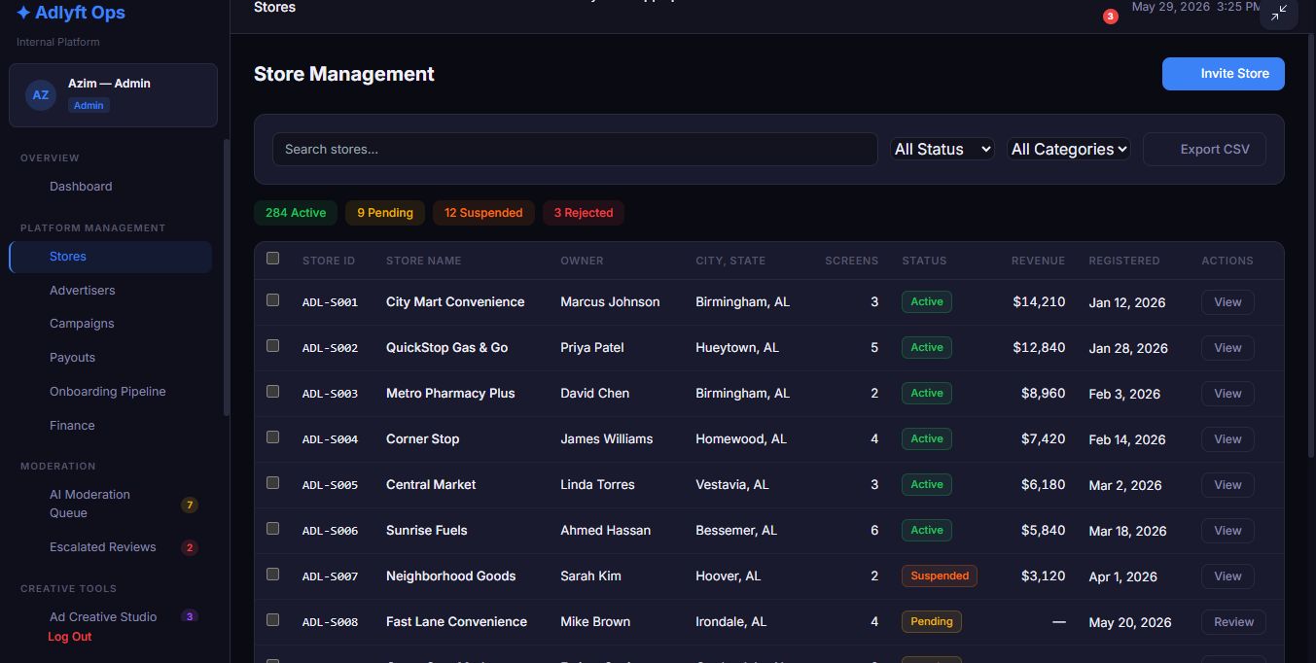

7.5 Advertiser Management Module
Full lifecycle management for all advertisers on the ADDLYFT platform.
Advertiser Table Columns: Advertiser ID, Business Name, Contact Email, Plan, Active Campaigns, Total Spend, Joined Date, Status, Actions.
Filter Controls:
- Filter by Status: 1,042 Active 28 Pending 14 Suspended
- Filter by Plan: Starter, Growth, Pro
Actions: View Details, Edit, Suspend, Reactivate, Export CSV, Add Advertiser (manual admin entry).
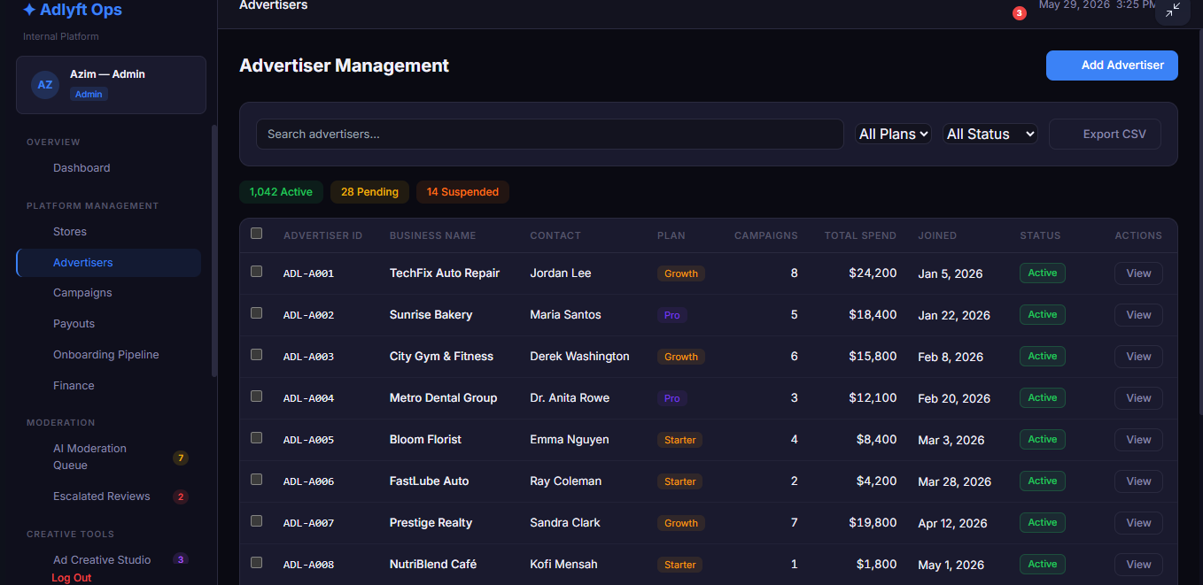

7.6 Campaign Management Module
Full campaign lifecycle management with status-based filtering and individual campaign actions.
Campaign Table Columns: Campaign ID, Campaign Name, Advertiser, Target Stores (count), Screens, Status, Start Date, End Date, Total Value, Actions.
Tab-Based Status Filter with Counts:
- All (317) | Pending Review (18) | Active (247) | Paused (12) | Completed (28) | Rejected (12)
Individual Campaign Actions: Approve, Reject (with mandatory reason field), Pause, Resume, View Details. Export functionality for current filtered view must be available.
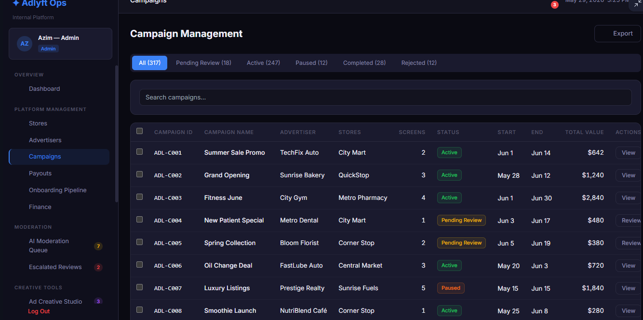

7.7 Payout Management Module
Manages all store owner payout disbursements including the $49/mo guaranteed minimum and referral commissions.
KPI Cards:

Card | Data Points
Pending Payouts | Total dollar amount + number of requests pending
Processing | Total dollar amount + count currently being processed
Paid This Month | Total dollar amount + count successfully paid this month
Failed | Total dollar amount + count of failed payouts requiring attention

Payout Table Columns: Payout ID, Store Name, Owner, Bank Account Info (masked), Amount, Request Date, Status, Actions.
Bulk Action: "Process All Pending" button — displays total amount to be disbursed in a confirmation dialog before execution.
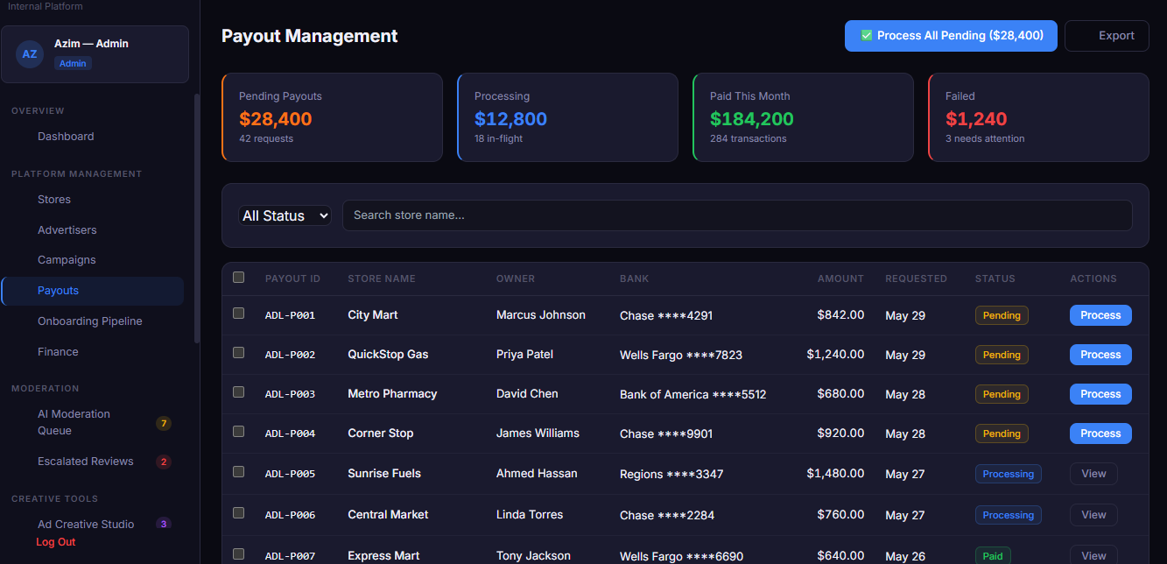

⚠ Failed Payout Alert
A persistent banner must appear at the top of the Payout module whenever any payouts have a Failed status. The banner must display the count of failed payouts and the total dollar amount at risk. Admins must be able to retry failed payouts individually or in bulk from this banner.

7.8 Store Onboarding Pipeline Module
A visual, stage-based tracking view of all stores currently moving through the onboarding process from initial submission to final approval.
Pipeline Stages (in order):
- Submitted
- Documents Review
- Verification Call
- Final Approval
- Approved
Per-Store Card Data: Store Name, Owner, Location (City, State), Days in Current Stage, Pipeline Entry Date.
Pipeline Metrics Header: Average Time in Pipeline (days), On-Time Approval Rate (%), Overdue Count. 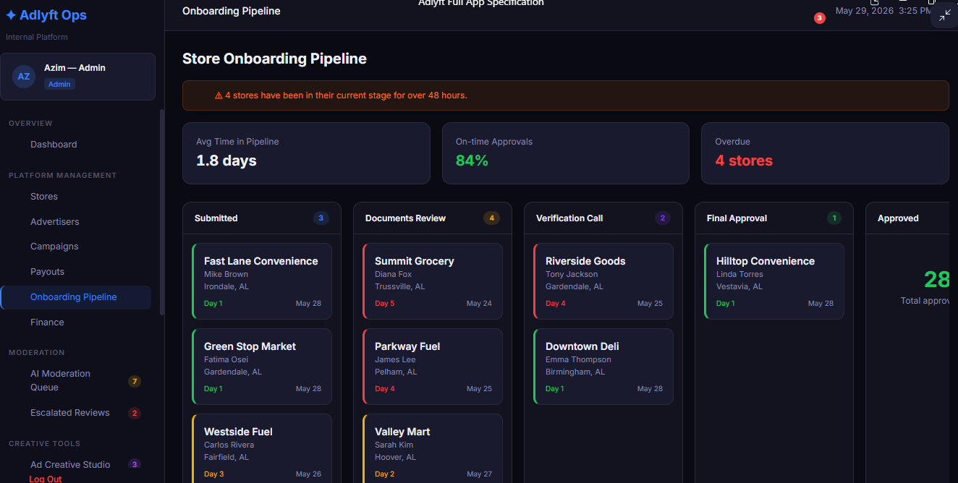

⚠ Overdue Alert Requirement
Any store that has been in the same pipeline stage for more than 48 hours must be visually flagged (e.g., highlighted border, overdue badge) within the pipeline view. Ops admins must be able to filter the pipeline view to show only overdue stores. An overdue notification must also appear in the sidebar badge for this module.

7.9 Finance & Reconciliation Module
Provides the ADDLYFT finance team with a comprehensive financial overview and transaction-level reconciliation capability.
Summary KPIs: Gross Revenue (30d), Platform Fees collected, Store Payouts disbursed, Net Profit, Outstanding amounts, Failed transaction totals.
Charts:
- Revenue vs. Payouts (30-day dual-line chart) — one line for gross revenue, one for total store payouts
- Fee Breakdown by Plan (chart) — showing fee revenue attributed to each subscription plan tier
Transaction Reconciliation Table:

Column | Data
Date | Transaction date
Transaction ID | Unique system ID
Type | Campaign Charge, Subscription Charge, Payout, Refund, Top-Up
Related Entity | Advertiser name or Store name
Gross Amount | Total transaction amount
Platform Fee | Fee retained by ADDLYFT
Net Amount | Amount after fee deduction
Status | Completed, Pending, Failed

Export Options: Revenue CSV, Payout Ledger CSV, Tax Summary PDF.
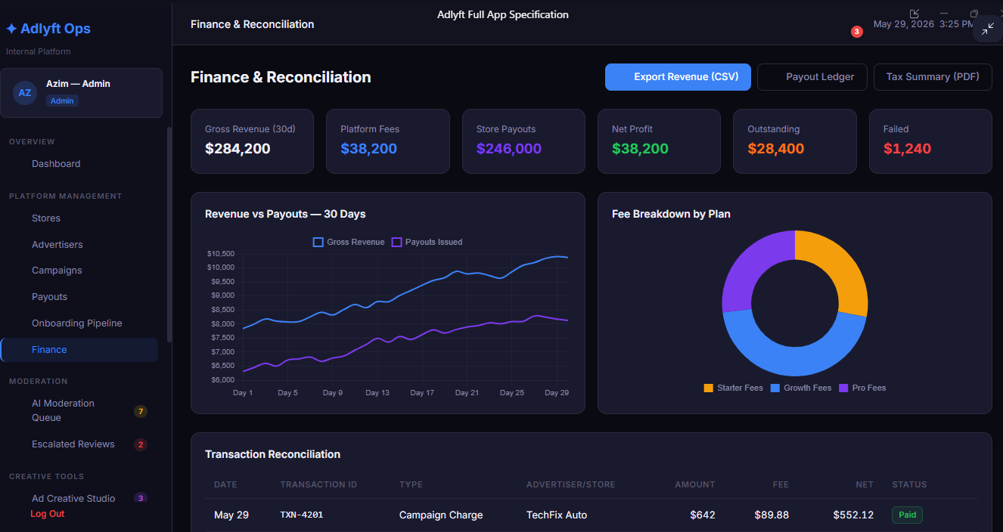

7.10 AI Moderation Queue
A review queue for AI-generated content that has been automatically flagged for human review before activation.
- Badge counts displayed: Queue (7 pending), Escalated (2 awaiting senior review)
- Each queue item displays: Store Owner name, content type, full content preview (script text for audio/video, caption for social), flag reason
- Moderator actions per item: Approve (content goes live), Reject (with mandatory reason), Escalate (moves to Escalated Reviews sub-module)
- Escalated items must be reviewable by a senior admin-level role only
- 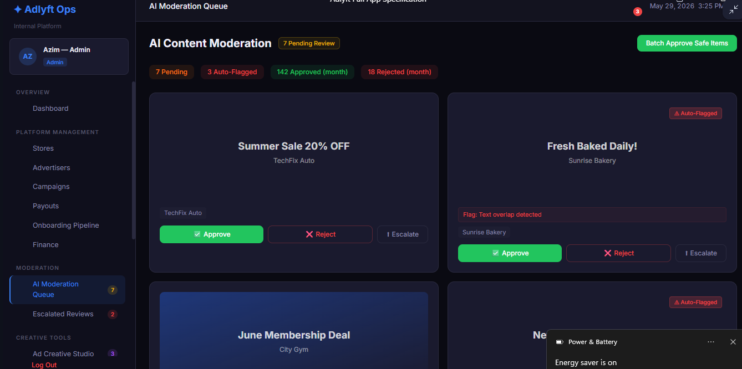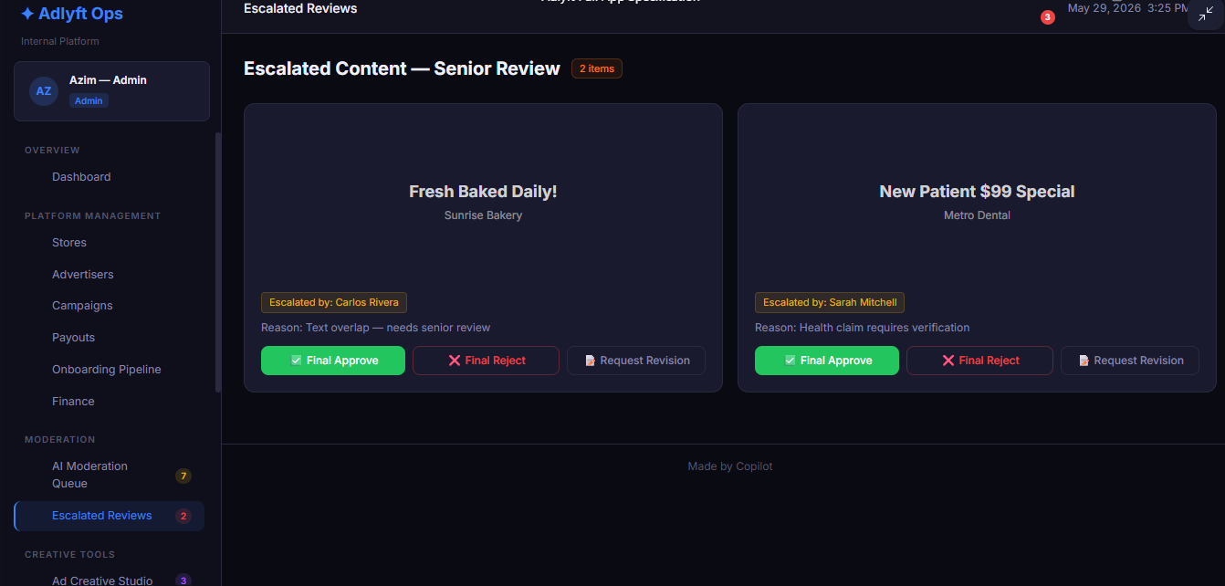

7.11 Ad Creative Studio
An internal content creation tool enabling ADDLYFT staff to manually generate ad creative on behalf of advertisers who require assistance.
- Pending requests badge displayed: 3 requests awaiting creative generation
- Uses the same AI generation engine as ADDLYFT Go (shared integration)
- Output: Audio Script (15s), Video Script (10s), Social Post — same three-card display as the store owner-facing AI Studio
- Generated content is associated with the requesting advertiser's account and submitted for moderation before activation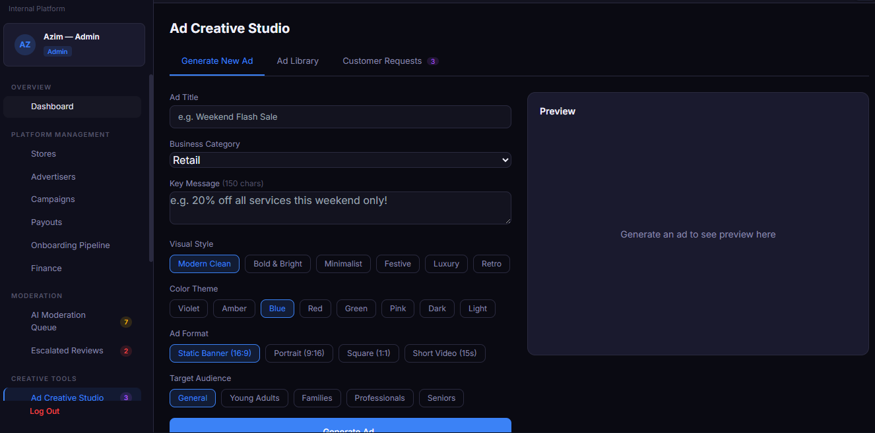

7.12 Configuration Modules

Module | Functionality
Pricing Config | Manage subscription plan pricing, tier feature toggles, AI token top-up bundle pricing. Changes must not require a code deployment — all prices must be configurable from this interface.
Notification Center | Configure and send platform-wide or targeted push/email notifications to store owners, advertisers, or both. Includes template management for transactional notification types.
System Health | Real-time monitoring dashboard for service uptime, screen health network-wide (Online / Offline / Maintenance counts), API status and response times, third-party integration health (payment processor, AI API, music API).
Platform Settings | Global platform configuration including: $49 guarantee amount (configurable), referral commission rate (configurable, default 40%), free trial duration (configurable, default 7 days), MVP discount percentage (configurable), feature flags.

7.12.1 Configuration Module Reference Screens

7.13 Support Tickets Module
Manages inbound support requests from both store owners and advertisers.
Ticket Table Columns: Ticket ID, Submitter Name, Submitter Type (Store Owner / Advertiser), Category, Priority (Low / Medium / High / Urgent), Status (Open / In Progress / Resolved / Escalated), Created Date, Assigned To, Actions.
Actions per Ticket: Assign (to an ops team member), Reply (internal note or customer-facing reply), Resolve (closes ticket), Escalate (elevates priority and flags for senior review).
Default view: Open tickets ordered by priority descending, then by creation date ascending (oldest high-priority first). 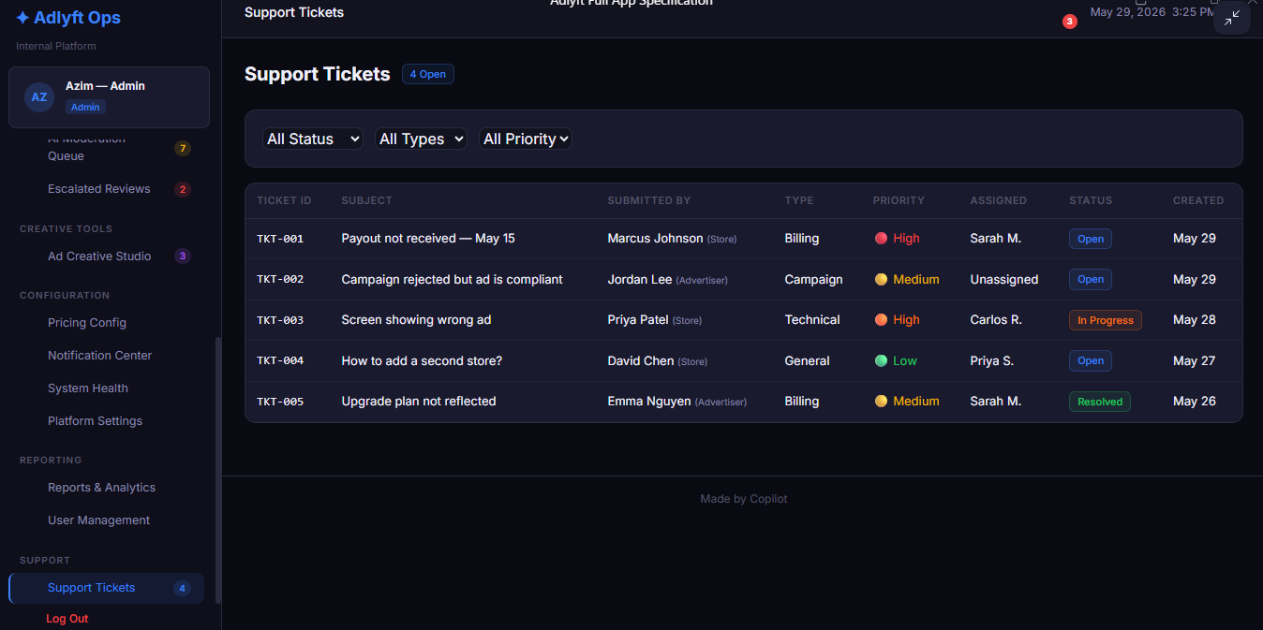

7.14 Dynamic Discount Management
ADDLYFT Ops will include a Discount Management Module that allows internal staff to:
- Create Discounts
Percentage-based discounts
Fixed-amount discounts
One-time credits
Recurring monthly credits
Campaign-specific discounts
- Apply Discounts
Discounts can be applied to:
Individual store accounts
Individual advertiser accounts
Specific campaigns
Specific billing cycles
Specific subscription plans
- Modify or Remove Discounts
Ops users can:
Adjust discount amount
Extend or shorten discount duration
Remove discount entirely
Override discount for special cases
- Discount Visibility
Discounts must be visible in the account’s billing history
Discounts must be reflected in invoices
Discounts must be logged for audit purposes
To prevent misuse, the following rules apply:
- Role-Based Access
Only authorized Ops roles may:
Create discounts
Modify discounts
Apply discounts
Remove discounts
- Audit Logging
Every discount action must be logged with:
User ID
Timestamp
Discount type
Discount amount
Affected account
Reason code
- Expiration Enforcement
All discounts must have:
A defined start date
A defined end date
Automatic expiration
- Reporting
ADDLYFT Ops must generate:
Monthly discount usage reports
Revenue impact reports
Store-level and advertiser-level discount summaries

8. Hardware Requirements

8.1 Hardware Devices Overview
ADDLYFT will deploy two dedicated hardware devices inside each partner store:
- ADDLYFT Audio Device
Connects to store speakers via Bluetooth
Plays AI-generated audio ads
Operates independently of the video device
- ADDLYFT Video Device
Connects to store TV via HDMI
Plays AI-generated video ads
Operates independently of the audio device
Both devices must:
- Run ADDLYFT Player OS (Android-based or Linux-based)
- Auto-start on power restoration
- Cache content locally
- Continuing playback during network outages
- Sync with the cloud when online
- Report on health status to ADDLYFT Ops

8.2 ADDLYFT Audio Device — Detailed Requirements

8.2.1 Purpose
The Audio Device plays scheduled audio ads through the store’s speaker system using Bluetooth. It must operate reliably even with unstable internet.

8.2.2 Hardware Specifications
- CPU: ARM-based or x86 mini-PC
- RAM: Minimum 2GB
- Storage: Minimum 16GB local storage
- Connectivity:
  - Wi-Fi (2.4GHz/5GHz)
  - Bluetooth 5.0 or higher
- Power: 5V/12V adapter
- OS: Android or Linux (customized for ADDLYFT Player)

8.2.3 Functional Requirements

8.2.3.1 Bluetooth Audio Output
- Must pair with store speakers
- Must auto-reconnect if Bluetooth drops
- Must support:
  - A2DP profile
  - SBC/AAC codecs

8.2.3.2 Local Content Caching
- Device must download and store:
  - Next 24–72 hours of audio ads
- Cache must survive:
  - Power outage
  - Network outage
  - Device reboot

8.2.3.3 Offline Playback
- Device must continue playing ads without internet for:
  - Minimum: 6 hours
  - Target: 24 hours
  - Ideal: 72 hours

8.2.3.4 Auto-Start Behavior
- On power restoration:
  - Device boots automatically
  - ADDLYFT Player auto-launches
  - Playback resumes without user input

8.2.3.5 Network Fluctuation Handling
- If network drops:
  - Continue playing cached ads
  - Queue logs locally
- When network returns:
  - Sync logs
  - Download new ads
  - Update playlist

8.2.3.6 Playback Logic
- Device receives playlist JSON from backend
- Plays ads in scheduled order
- Volume normalization required
- Optional Crossfade

8.2.4 Non-Functional Requirements
- Uptime: 99%
- Latency: < 200ms between ads
- Bluetooth reconnect time: < 5 seconds
- Local storage encryption required

8.2.5 Device Health Reporting
Device must send heartbeat every 60 seconds containing:
- Device ID
- Store ID
- Bluetooth status
- Network status
- Storage usage
- Current ad playing
- Error logs
If heartbeat fails for 5 minutes → mark device as offline.

8.3 ADDLYFT Video Device — Detailed Requirements

8.3.1 Purpose
The Video Device plays scheduled video ads on the store’s TV using HDMI. It must operate reliably even with unstable internet.

8.3.2 Hardware Specifications
- CPU: ARM or x86 mini-PC
- RAM: Minimum 4GB
- Storage: Minimum 32GB
- Connectivity:
  - Wi-Fi (2.4GHz/5GHz)
  - Optional Ethernet
- Output:
  - HDMI 1080p or 4K
- OS: Android TV or Linux

8.3.3 Functional Requirements

8.3.3.1 HDMI Video Output
- Must support:
  - 1080p (required)
  - 4K (optional)
- Auto-detect TV resolution
- Auto-reconnect if HDMI signal drops

8.3.3.2 Local Video Caching
- Must store:
  - Next 24–72 hours of video ads
- Cache must survive:
  - Power outage
  - Network outage
  - Device reboot

8.3.3.3 Offline Playback
- Must continue playing cached videos for:
  - Minimum: 6 hours
  - Target: 24 hours
  - Ideal: 72 hours

8.3.3.4 Auto-Start Behavior
- On power restoration:
  - Device boots automatically
  - ADDLYFT Player auto-launches
  - Playlist resumes

8.3.3.5 Network Fluctuation Handling
- If network drops:
  - Continue playing cached videos
  - Queue proof-of-play logs locally
- When network returns:
  - Sync logs
  - Download new videos
  - Update playlist

8.3.3.6 Playback Logic
- Device receives playlist JSON
- Plays videos in loop or schedule
- Supports:
  - MP4 (H.264/H.265)
  - 15–30 second ads
- Must prevent screen burn-in

8.3.4 Non-Functional Requirements
- Uptime: 99%
- Video load time: < 500ms
- Local storage encryption required
- Smooth playback without stutter

8.3.5 Device Health Reporting
Heartbeat every 60 seconds containing:
- Device ID
- Store ID
- HDMI status
- Network status
- Storage usage
- Current video playing
- Error logs
If heartbeat fails for 5 minutes → mark device as offline.

8.4 Shared Requirements (Audio + Video Devices)

8.4.1 Security
- Device must use:
  - Encrypted local storage
  - HTTPS for all API calls
  - Signed playlists
  - Device authentication tokens

8.4.2 Remote Management
ADDLYFT Ops must be able to:
- Restart device
- Push updates
- Update playlists
- View logs
- View device health

8.4.3 Local Logging
Device must store:
- Playback logs
- Error logs
- Network logs
- Bluetooth/HDMI logs
Logs must be synced when online.

8.5 Failure & Edge Case Handling

Power Outage
- Device auto-boots
- Auto-launches ADDLYFT Player
- Resumes playback from cache

Network Outage
- Continue playing cached ads
- Queue logs locally
- Retry sync every 5 minutes

Bluetooth Failure (Audio Device)
- Auto-reconnect
- If fails 3 times:
  - Switch to internal speaker fallback (optional)

HDMI Failure (Video Device)
- Auto-reconnect
- If fails 3 times:
  - Display error screen

8.6 Device Lifecycle

Provisioning
- Device assigned to store
- Device ID registered
- Playlist downloaded

Operation
- Continuous playback
- Heartbeat monitoring
- Auto-updates

Maintenance
- Remote troubleshooting
- Firmware updates
- Device replacement if needed

9. Functional Requirements Summary

All functional requirements are listed below with unique identifiers, module assignment, priority classification, and developer notes. Priority levels: Must Have (MVP-critical), Should Have (MVP-preferred, may defer if timeline-constrained), Could Have (post-MVP consideration).

9.1 ADDLYFT Go — Store Owner App

Req ID | Module | Requirement | Priority | Notes
REQ-GO-001 | Onboarding | System must support a 7-step guided registration flow with a persistent progress indicator showing current step and total step count | Must Have | Back navigation must preserve entered data
REQ-GO-002 | Onboarding | Business Type dropdown must include predefined categories as specified in Section 5.2 | Must Have | Stored as enum in DB
REQ-GO-003 | Onboarding | Daily customer footfall must be collected using a dropdown with exactly 10 predefined ranges (Up to 250/day through 5,000/day) | Must Have | Used for advertiser targeting matching
REQ-GO-004 | Subscription | Three subscription tires must be available: Single Channel ($39.99/mo), Dual Channel ($79.99/mo), Full Bundle ($99.99/mo) | Must Have | Prices configurable via Ops Pricing Config module
REQ-GO-005 | Subscription | 7-day free trial must be enforced: no charge to payment method until 7 days after signup. Trial period enforced at payment processor level. | Must Have | Trial duration configurable in Platform Settings
REQ-GO-006 | Subscription | Multi-store support (adding multiple store locations) must be available on the Full Bundle plan | Must Have | Each store billed at plan rate; cost updates dynamically in Step 4
REQ-GO-007 | Payment | Three payment methods must be supported: Credit/Debit Card (Visa, Mastercard, AMEX), Bank Account via ACH, and PayPal | Must Have | All via Stripe integration (recommended)
REQ-GO-008 | AI Studio | A single AI generation action must produce three content outputs simultaneously: Audio Script (15s), Video Script (10s), and Social Post | Must Have | All three outputs from one LLM API call; displayed as three side-by-side cards
REQ-GO-009 | AI Studio | Each AI generation action must deduct token from the user's monthly token allocation. Token count must update immediately after generation. | Must Have | Atomic decrement required; race conditions must be prevented
REQ-GO-010 | AI Studio | AI Token top-up packs must be purchased in-app: 10 extra tokens for $4.99, 25 extra tokens for $9.99, and 50 extra tokens for $17.99 | Must Have | Pricing configurable via Ops Pricing Config
REQ-GO-011 | AI Studio | Optional image upload (PNG/JPG, max 5MB) must be supported as context input for the AI generation engine | Must Have | Image stored temporarily for generation context; not persisted long-term
REQ-GO-012 | Content | Content scheduling must support selection by time of day (Morning, Afternoon, Evening, Night) and day of week (individual day checkboxes) | Should Have | Schedule stored per content item
REQ-GO-013 | Content | Content status management must support three states: Live (currently active in rotation), Scheduled (queued for future activation), Draft (created but not yet scheduled) | Must Have | State transitions must be logged
REQ-GO-014 | Audio Engine | In-store audio cycle must follow the sequence: ~2-minute song → 5-second fade → Ad 1 (15s) → Ad 2 (15s) → next song → repeat | Must Have | Timing managed server-side; store device receives schedule
REQ-GO-015 | Audio Engine | Per-store music preferences must be configurable: Genre (multi-select, 16 options), Language (single or mixed, 11 options), Mood & Style (multi-select, 10 options), Popularity (single-select, 5 options), Favorite Artists (tag input), Explicit Lyrics toggle | Must Have | Preferences stored per store record; passed to music API
REQ-GO-016 | Analytics | Analytics tab must display: Total Ad Plays, Audience Reached, Social Impressions, and Daily Average for the selected time (Today / This Week / This Month) | Should Have | Data sourced from analytics tracking service
REQ-GO-017 | Analytics | A time-of-day heatmap grid (Days of Week × Time Slots) must be displayed in the Analytics tab showing play intensity per cell | Should Have | Grid: Mon–Sun columns × Morning/Afternoon/Evening/Night rows
REQ-GO-018 | Revenue | Each active store must receive a guaranteed minimum payout of $49/month regardless of advertiser revenue generated by that store. Payout should only trigger if the customer stays with ADDLYFT for minimum of 3 Months, Payout will be Quarterly. | Must Have | Guarantee amount configurable in Platform Settings; enforced in payout logic
REQ-GO-019 | Referral | Each store owner must receive a unique referral code generated at account creation in the format ADDLYFT-[NAME]-[4-digit number] | Must Have | Code must be unique system-wide; collision detection required
REQ-GO-020 | Referral | Store owners must automatically receive a 40% commission on the total monthly ad spend of any advertiser they refer to the platform via their referral code. Payment will be Added Monthly. | Must Have | Commission rate configurable in Platform Settings; paid automatically on billing cycle
REQ-GO-021 | Promotions | A pre-built promotions library with templates must be available for store owners to browse, preview, and schedule without consuming AI tokens | Must Have | Content curated by ADDLYFT team; managed via Ops CMS

9.2 ADDLYFT Reach — Advertiser App

Req ID | Module | Requirement | Priority | Notes
REQ-RC-001 | Onboarding | Advertiser registration flow must include business verification steps to confirm business legitimacy before account activation. The Business should not be the same or similar Business type as the ADDLYFT Go Business. | Must Have | Verification method TBD by engineering team (manual review or automated check)
REQ-RC-002 | Campaigns | Campaign creation must support upload and submission of both audio (15-second) and video (10-second) ad formats | Must Have | File type and resolution constraints to be confirmed by engineering; stored in file storage (S3)
REQ-RC-003 | Targeting | Advertisers must be able to select specific store locations from the live ADDLYFT store network as campaign targets. Similar Doing Business will not be able to select by Advertiser and will be shown as not allowed. | Must Have | Store selection UI must support geographic filtering (city, ZIP, business type)
REQ-RC-004 | Campaigns | Campaign lifecycle must support the following states with correct transitions: Pending Review → Active → Paused / Completed / Rejected | Must Have | State transitions: Pending→Active (Ops approval), Active→Paused (advertiser/admin), Active→Completed (system, date-triggered), Pending→Rejected (Ops rejection)
REQ-RC-005 | Pricing | Five advertiser plan tiers must be implemented: Base, Standard, Plus, Premium and Executive — each governing campaign limits, store location access, and reporting depth | Must Have | Exact pricing TBD; tier config must be manageable via Ops Pricing Config without code change
REQ-RC-006 | Analytics | Real-time campaign performance analytics must be available showing impressions, plays, and CPM per campaign and per store location | Must Have | Data must reflect ad plays within 5 minutes of occurrence
REQ-RC-007 | Pricing | A MVP launch discount must be automatically applied for early advertiser adopters during the launch promotion period | Should Have | Discount period end date and mechanism configurable via Platform Settings; discount tracked in transaction ledger

8.3 ADDLYFT Ops — Internal Operations App

Req ID | Module | Requirement | Priority | Notes
REQ-OPS-001 | Dashboard | Real-time KPI cards must display: Active Stores, Active Advertisers, Live Campaigns, Today's Revenue, Pending Approvals, Flagged Content — all refreshing within 5 seconds | Must Have | WebSocket or SSE for real-time push recommended
REQ-OPS-002 | Dashboard | A real-time activity feed must display timestamped platform events in chronological order | Must Have | Event types listed in Section 7.3
REQ-OPS-003 | Stores | Full CRUD operations must be available for store records with status management supporting: Active, Pending, Suspended, Rejected | Must Have | All state changes logged with admin user ID and timestamp
REQ-OPS-004 | Stores | Bulk approval and bulk suspend actions must be available for selected stores; confirmation dialog must list affected stores before execution | Must Have | Bulk actions must be atomic; partial failure must roll back the entire batch
REQ-OPS-005 | Advertisers | Full CRUD operations for advertiser records with plan management (Base, Standard, Plus, Premium and Executive) and status management (Active / Pending / Suspended) | Must Have | Plan changes must trigger billing recalculation
REQ-OPS-006 | Campaigns | Full campaign lifecycle management must be available with individual actions: Approve, reject (with mandatory rejection reason), Pause, Resume, View Details | Must Have | Rejection reason stored in campaign record; advertiser notified automatically
REQ-OPS-007 | Payouts | Payout processing must support full status tracking: Pending, Processing, Paid, Failed — with visibility into all payout records | Must Have | Failed payouts must trigger alert banner in module UI
REQ-OPS-008 | Payouts | "Process All Pending" bulk action must be available; confirmation dialog must display total dollar amount to be disbursed before execution | Must Have | Individual payout processing must also remain available
REQ-OPS-009 | Pipeline | A visual onboarding pipeline must display all stores currently progressing through the 5 stages: Submitted → Documents Review → Verification Call → Final Approval → Approved | Must Have | Kanban-style board or stage-column layout; stores moveable between stages
REQ-OPS-010 | Pipeline | Stores that have been in any pipeline stage for more than 48 hours must be automatically flagged as overdue with a visible indicator | Must Have | Overdue check must run as a scheduled job (minimum every 15 minutes); overdue count shown in sidebar badge
REQ-OPS-011 | Finance | Revenue vs. Payout reconciliation must be available as a 30-day dual-line chart comparing gross revenue against total payout disbursements | Must Have | Data must match transaction ledger totals exactly; discrepancy alert if they diverge
REQ-OPS-012 | Finance | Transaction ledger must be exportable as Revenue CSV, Payout Ledger CSV, and Tax Summary PDF | Must Have | PDF generation must use server-side rendering; client-side PDF generation not acceptable
REQ-OPS-013 | Moderation | AI content moderation queue must support approval, reject (with reason), and escalate actions per flagged content item | Must Have | Escalated items accessible only to admin-level roles; standard moderators cannot resolve escalated items
REQ-OPS-014 | Screens | Screen health monitoring must display network-wide counts and percentages for: Online, Offline, and Maintenance status categories | Must Have | Shown on Ops Dashboard and in System Health module; offline threshold must trigger alert
REQ-OPS-015 | Support | Support ticket management must support: Assign, Reply, Resolve, and Escalate actions with priority and status tracking | Should Have | Initial open ticket count shown in prototype: 4 open tickets

10. Non-Functional Requirements

Non-functional requirements govern the quality, reliability, security, and performance characteristics of the ADDLYFT platform. These requirements are not optional; they represent baseline operational standards that must be met across all three products.

Req ID | Category | Requirement | Priority
REQ-NF-001 | Performance | Dashboard KPIs and the real-time activity feed in ADDLYFT Ops must refresh and reflect live platform events within 5 seconds of those events occurring | Must Have
REQ-NF-002 | Security | All payment data collection and processing must be handled by a PCI-DSS Level 1 compliant payment processor. No raw card data may be stored on ADDLYFT infrastructure at any point. | Must Have
REQ-NF-003 | Security | All API endpoints across all three products must require authentication via JWT (JSON Web Token) or a functionally equivalent stateless authentication mechanism | Must Have
REQ-NF-004 | Security | All sensitive user data — including PII, financial information, and bank details — must be encrypted at rest (AES-256 or equivalent) and in transit (TLS 1.2 minimum, TLS 1.3 preferred) | Must Have
REQ-NF-005 | Availability | All customer-facing services (ADDLYFT Go, ADDLYFT Reach) must achieve a minimum uptime SLA of 99.5% measured monthly, equating to no more than approximately 3.6 hours downtime per month | Must Have
REQ-NF-006 | Scalability | The platform architecture must support a minimum of 10,000 concurrent store dashboard sessions without performance degradation | Should Have
REQ-NF-007 | Compatibility | ADDLYFT Ops must be fully functional on the latest two major versions of: Google Chrome, Apple Safari, Mozilla Firefox, and Microsoft Edge. ADDLYFT Go and ADDLYFT Reach app Must be supported on Android and IOS Device. | Must Have
REQ-NF-008 | Responsiveness | All web interfaces for ADDLYFT Go and ADDLYFT Reach must be fully responsive and usable on both mobile devices and desktop browsers without native app installation | Must Have
REQ-NF-009 | AI Performance | AI content generation (audio script + video script + social post) must complete and return all three outputs within 10 seconds under normal system load conditions | Must Have
REQ-NF-010 | Audit & Logging | All administrative actions performed within ADDLYFT Ops — including store approvals/rejections, campaign approvals/rejections, payout processing, and configuration changes — must be logged with: action type, timestamp (UTC), admin user ID, and affected entity ID | Must Have

11. Data Requirements

10.1 Core Data Entities
The following table defines all primary data entities required to support the ADDLYFT platform. All entities must have a unique system-generated ID (UUID recommended) and timestamp fields (created_at, updated_at) unless noted.

Entity | Key Fields | Notes
Store Owner (User) | ID, First Name, Last Name, Email (unique), Phone, Password Hash, Referral Code, Role, Account Status, Joined Date | Email must be unique system-wide. Password stored as bcrypt hash only. Referral Code generated at creation.
Store | ID, Owner ID (FK), Store Name, Address, City, State, ZIP, Phone, Website (nullable), Business Type, Footfall Range, Plan Type, Status, Registration Date, Screen Count | FK to Store Owner (User). Multiple stores may share one Owner ID (Full Bundle plan).
Subscription | ID, Store ID (FK), Plan Type, Monthly Price, Trial Start Date, Trial End Date, Next Billing Date, Billing Status, Payment Method Reference, Promo Code (nullable) | Tracks full billing lifecycle per store. One subscription record per store.
Content | ID, Store ID (FK), Type (Audio / Video / Social), Title, Script Text, Status (Live / Scheduled / Draft), Scheduled Days, Scheduled Times, Created Date, Last Modified Date | Linked to Store. Content type governs which audio cycle slot it occupies.
AI Token Ledger | ID, Store ID (FK), Month, Year, Tokens Allocated, Tokens Used, Tokens Remaining, Top-Up Tokens Purchased | One record per store per calendar month. Resets on billing date each month. Top-up tokens carry over within the same month.
Advertiser | ID, Business Name, Contact Name, Email, Phone, Plan Tier, Status, Referred By (Store Owner ID, nullable), Joined Date, Total Lifetime Spend | Referred By field used to calculate referral commissions. Unique email constraint.
Campaign | ID, Advertiser ID (FK), Campaign Name, Ad Format (Audio / Video), Ad File URL, Target Store IDs (array), Start Date, End Date, Status, Total Campaign Value, CPM, Rejection Reason (nullable) | Target Store IDs is an array of Store IDs. Ad File URL points to file storage (S3). Status transitions logged.
Payout | ID, Store ID (FK), Owner ID (FK), Amount, Payout Type (Guarantee / Referral Commission / Advertiser Revenue), Bank Details Reference (encrypted), Status, Requested Date, Processed Date, Failure Reason (nullable) | Bank Details stored as encrypted reference — never plaintext. Payout Type distinguishes guaranteed income from earned income.
Referral | ID, Referrer Store Owner ID (FK), Referred Advertiser ID (FK), Commission Rate (default 40%), Monthly Spend Amount, Monthly Commission Amount, Month, Year, Paid Status, Paid Date | One record per referrer-advertiser pair per month. Commission Rate sourced from Platform Settings at time of calculation.
Transaction | ID, Type (Campaign Charge / Subscription Charge / Payout / Refund / Top-Up), Related Entity ID, Related Entity Type, Gross Amount, Platform Fee, Net Amount, Status, Transaction Date, Payment Processor Reference | Authoritative financial record for reconciliation. All monetary events must create a transaction record.
Moderation Queue | ID, Content ID (FK), Flagged Reason, Status (Queued / Approved / Rejected / Escalated), Reviewed By (Admin User ID, nullable), Review Date (nullable), Rejection Reason (nullable) | Auto-populated when AI generation triggers a content flag. Escalated items require admin-level role to resolve.
Support Ticket | ID, Submitter ID (FK), Submitter Type (Store Owner / Advertiser), Category, Priority (Low / Medium / High / Urgent), Status (Open / In Progress / Resolved / Escalated), Created Date, Assigned To (Admin User ID, nullable), Resolution Notes | Linked to either Store Owner or Advertiser record depending on Submitter Type.

12. Integration Requirements

The following third-party integrations are required to deliver the ADDLYFT platform's full functionality. Engineering team must confirm vendor selections and obtain API credentials prior to development of dependent features.

Integration | Recommended Vendor | Purpose | Priority
Payment Processor | Stripe (recommended) | Process subscription charges, one-time top-up purchases, ACH bank transfers, PayPal payments, and outbound payout disbursements to store owners. Must support PCI-DSS compliance offloading, trial period management, and webhook-based event notifications. | Must Have
AI Language Model API | TBD by engineering team | Generate all AI content: audio scripts (15s format), video scripts (10s format), and social media posts from user text prompts and optional image context. Must respond within 10 seconds under normal load. | Must Have
Music Streaming / Licensing API | TBD — requires licensed music sources. Possibly we can use some free source for MVP | Source licensed music tracks for in-store audio playback. Must support filtering by genre, mood, language, popularity tier, and explicit content flag. Licensing must be cleared up for commercial in-store use prior to production launch. Pixabay Music (BEST + SAFE + FREE)  License: Pixabay License (commercial use allowed, no attribution, no copyright) Use in ADDLYFT: ✔ Audio ads ✔ Background music ✔ In-store playback  This is the #1 safest source for ADDLYFT.  - No copyright  - No attribution  - No royalties  - No ads  - No hidden restrictions  - Clean MP3 files  - Commercial use allowed | Must Have
SMS / Push Notification Service | Twilio (SMS), Firebase (Push) | Deliver real-time alerts to store owners and advertisers including: trial expiry reminders, payout notifications, campaign approval/rejection alerts, and platform announcements. | Must Have
Email Service Provider | SendGrid or AWS SES | Send all transactional emails: welcome emails, subscription receipts, payout confirmations, campaign status updates, password resets, and billing notifications. | Must Have
Analytics & Event Tracking | Custom service / TBD | Track and store all ad play events, impressions, and audience count data per store and per campaign. Must support near-real-time data availability (<5 minutes) for both store owner and advertiser analytics dashboards. | Must Have
File Storage | AWS S3 (recommended) | Store all uploaded ad creative files (audio files, video files), user-uploaded images for AI generation context, and any other binary assets. Access must be controlled via signed URLs with appropriate expiration policies. | Must Have

ⓘ Note for Engineering Team
The music licensing integration is a pre-production dependency. The engineering team must advise the product owner on available licensed music API vendors (e.g., Pixabay, Soundtrack Your Brand, Mood Media API, or an equivalent royalty-free library) before the audio engine feature can be signed off for production deployment. This risk must be tracked in the project timeline.

13. User Roles & Permissions

The ADDLYFT platform defines five distinct user roles with strictly scoped access controls. The system must enforce role-based access control (RBAC) at the API level — not solely in the UI — to prevent unauthorized access to data or actions.

Role | Access Scope | Capabilities
Store Owner | Restricted to own account and store(s) data only | Complete 7-step onboarding; access dashboard (Overview, Promotions, AI Studio, My Content, Analytics, Audio, Revenue, Referral, Settings tabs); manage own content and schedules; purchase AI token top-ups; update billing and account settings. Cannot view any other store owner's data.
Advertiser | Restricted to own account and campaigns only | Complete advertiser onboarding; create and manage campaigns; select target store locations from live network; view own campaign analytics; manage billing and account settings. Cannot view other advertisers' data or store owner records.
Ops Admin | Full access to all ADDLYFT Ops modules | All platform management actions: store CRUD, advertiser CRUD, campaign approval/rejection/management, payout processing, pipeline management, finance reconciliation, moderation queue (including escalated), ad creative studio, all configuration modules, reporting, user management, and support tickets.
Ops Moderator | Partial internal access — content and support only | View and action the AI Moderation Queue (approve/reject/escalate); view but not resolve Escalated Reviews; access Ad Creative Studio (generate content on behalf of advertisers); manage assigned Support Tickets (reply/resolve). Cannot access: store management, advertiser management, payout processing, finance module, or configuration modules.
Finance Admin | Finance-scoped internal access only | Full access to Payout Management module (view, process, retry failed payouts); full access to Finance & Reconciliation module; access to Reports & Analytics for financial reporting; export all financial reports (CSV, PDF). Cannot access: store or advertiser management, campaigns, moderation, or configuration modules.

14. Assumptions & Constraints

The following assumptions and constraints underpin the requirements in this document. If any assumption proves incorrect, the affected requirements must be revisited with the product owner before development proceeds on those features.
- Hardware: A speaker system capable of receiving and playing audio content must be present in-store. ADDLYFT Go and Reach manage the software-side audio scheduling and ad injection. Physical hardware (a Raspberry Pi device or Android-based device), along with the connected audio speakers and TV display, will be provided by ADDLYFT to the ADDLYFT Go client for activation and ongoing operation.
- $49/Mo Guarantee — Business Cost: The $49/month guaranteed minimum payout to store owners is a firm business commitment. The payout logic must enforce this unconditionally. Any shortfall between actual advertiser-generated revenue at a given store and $49 is absorbed as a platform operating cost. The engineering team must not introduce conditions or logic that could cause this guarantee to be withheld from an Active store.
- 40% Referral Commission Automation: The referral commission at 40% of the referred advertiser's total monthly ad spend must be calculated and added to the store owner's payout automatically at each billing cycle without manual intervention by the operations team.
- AI Vendor TBD: AI content generation is assumed to be powered by a third-party LLM API. The specific vendor has not been confirmed. Engineering team must select a vendor capable of meeting the 10-second response time requirement (REQ-NF-009) and return structured output suitable for audio/video script formatting.
- Music Licensing Pre-Requisite: A music licensing solution for the in-store audio engine must be confirmed and contracted prior to production launch. A licensed music API or an approved royalty-free music library must be used. Launching with unlicensed music is not permitted under any circumstances.
- USD Only: All monetary values displayed, processed, and stored by the platform are US Dollars (USD). No multi-currency logic is required for MVP.
- US Market Only: The platform will launch and operate exclusively in the United States for MVP. No international phone formats, address formats, tax rules, or currency conversions are required at this stage.

15. Acceptance Criteria

The following high-level acceptance criteria define the minimum conditions under which each product will be considered complete and ready for production launch. Detailed test cases will be derived from these criteria during the QA phase.

14.1 ADDLYFT Go — Acceptance Criteria

# | Criterion | Verification Method
AC-GO-01 | A first-time store owner can complete the entire 7-step onboarding flow — from account creation through payment checkout — in under 10 minutes without external assistance | User acceptance testing with representative store owner persona
AC-GO-02 | A single AI generation action produces all three content outputs (Audio Script 15s, Video Script 10s, Social Post) simultaneously and deducts exactly 1 token from the monthly allocation | Automated test + manual verification of token ledger
AC-GO-03 | Monthly token count resets to the plan allocation on each billing date without manual intervention; top-up tokens purchased within the month are consumed first | Billing cycle simulation test
AC-GO-04 | The $49/month guaranteed revenue is reflected in the payout ledger for every Active store on every billing cycle regardless of actual advertiser revenue generated by that store | Payout ledger audit across multiple billing cycles in staging environment
AC-GO-05 | Referral commissions (40% of referred advertiser's monthly spend) are accurately tracked, calculated, and credited to the referring store owner's payout ledger on the billing date | End-to-end referral tracking test with known test data
AC-GO-06 | Payment method is not charged during the 7-day free trial period; the first charge occurs on the exact day the trial expires | Integration test with Stripe sandbox environment

14.2 ADDLYFT Reach — Acceptance Criteria

# | Criterion | Verification Method
AC-RC-01 | An advertiser can create and submit a campaign targeting specific store locations from the ADDLYFT network within a single session, without requiring any support assistance | User acceptance testing with advertiser persona
AC-RC-02 | Campaign progresses through the correct lifecycle state sequence (Pending Review → Active upon Ops approval; Pending Review → Rejected upon Ops rejection); no invalid state transitions are possible | State machine unit tests + integration tests
AC-RC-03 | Campaign analytics (impressions, plays, CPM) reflect actual ad play events within 5 minutes of those events occurring | End-to-end analytics pipeline test with known ad play events
AC-RC-04 | The MVP launch discount is automatically applied to the first billing cycle for all early adopter advertisers without requiring manual admin action | Billing integration test in Stripe sandbox with new advertiser account creation

14.3 ADDLYFT Ops — Acceptance Criteria

# | Criterion | Verification Method
AC-OPS-01 | An Ops Admin can approve or reject a pending store in 3 clicks or fewer from the Stores module | Click-path audit during UAT
AC-OPS-02 | "Process All Pending" payout batch action successfully initiates disbursement for all pending payouts simultaneously; partial failures do not silently succeed — each failure is individually reported | Payout batch processing test in staging with mixed success/failure test cases
AC-OPS-03 | Finance reconciliation module totals (Gross Revenue, Payouts, Net) match the transaction ledger totals exactly for any selected date range | Data integrity audit comparing reconciliation view against raw transaction table
AC-OPS-04 | The onboarding pipeline correctly identifies and flags stores that have been in any single pipeline stage for more than 48 hours; flagged stores appear in the overdue count within 15 minutes of crossing the threshold | Timed staging test with manually staged stores exceeding 48-hour threshold
AC-OPS-05 | All admin actions (approvals, rejections, payout processing, configuration changes) are recorded in the audit log with the correct admin user ID, timestamp, action type, and affected entity ID | Audit log review after executing a controlled set of admin actions

ⓘ UAT Planning Note
Formal User Acceptance Testing (UAT) sessions should be scheduled for each product prior to production deployment. The product owner (Azim) will sign off on each acceptance criterion individually. A UAT tracker will be maintained separately from this BRD. Engineering team should not consider any product complete until UAT sign-off has been received in writing.

16. Revision History

This section tracks all versions of this document. All future changes must be recorded here with the version number, date of change, author, and a clear summary of what has changed.

Version | Date | Author | Changes / Notes
1.0 | June 4, 2026 | Azim — Product Owner | Initial BRD created from validated prototype and product specification for ADDLYFT Go, ADDLYFT Reach and ADDLYFT Ops.

Figure 3. ADDLYFT Ops configuration and system management reference screens.
ADDLYFT Platform — Business Requirements Document v1.1
Prepared by Azim — Product Owner | June 4, 2026 | Internal & Confidential
This document is the authoritative source of requirements for the ADDLYFT MVP build.

